CURRICULUM ON HEALTH
  - Strand W5: Fitness Training
  - Level 11
This Strand is composed of the following components:
- Army Physical Training
- Home Training
- Field Training

DESIRED OUTCOME (Self-Mastery) / PRACTICUM A
90% of Unit Cadets understand how physical fitness improves their overall health and quality of life and embrace a healthy lifestyle through exercise and nutrition.

Table of Contents
A. Army Physical Training 3
Objectives 3
A1. INTRODUCTION TO PHYSICAL FITNESS 4
A2. EXECUTION OF TRAINING …………………………………………………………………………………………………… 10
A3. PREPARATION DRILL (PD) 20
A4. ACTIVITIES 34
RUNNING 34
CIRCUIT TRAINING 37
GRASS DRILLS 44
SPORTS 47
A5. RECOVERY DRILL (RD) 49

Army Physical Training

Objectives

DESIRED OUTCOME (Self-Mastery) / PRACTICUM A
90% of Unit Cadets can properly perform Army style unit physical training, using recommended formations, drills and exercises, and innovative techniques to keep PT challenging, fun, and a significant part of their leadership training.

- Describe how Army style PT is used in the Cadet Corps program to build fitness and health, discipline, teamwork, and leadership. Note the limitations of Army style PT for teenagers.
- Properly enter into and assemble from an Extended Rectangular Formation at platoon or company level, implement the cadences of slow or moderate exercises, demonstrate the seven positions used in Army style PT exercises, and the commands and responses necessary to conduct stretches and exercises.
- Perform the ten exercises of the Preparation Drill using proper commands, starting positions, cadence, position at each count of the exercise, and check points.
- Describe the activities of running, circuit training, grass drills, sports, and unit Olympics regarding the options for a variety of training in each of these activities, how they’re conducted, and the benefits cadets receive from engaging in them.
- Perform the five exercises of the Recovery Drill using proper commands, starting positions, proper implementation of both positions of the exercise, and check points.

A1. INTRODUCTION TO PHYSICAL FITNESS

Physical fitness, health, and wellness is one of the pillars of the California Cadet Corps program, and one of the major values we try to instill in cadets. We want cadets to embrace a healthy lifestyle in both what is eaten and what is actively done, in hopes of building habits for lifelong wellness.

Physical fitness is a vast topic. Experts have defined 8 dimensions of wellness and fitness: physical, emotional, intellectual, social, occupational, financial, spiritual, and environmental. This section will focus on several specific areas within the Cadet Corps curriculum; mostly Army style physical training, and other training that can be done to get and stay fit. The W3 strand looks at the physiological aspects of fitness, as well as fitness training. Both are important aspects to knowing what to do in planning a fitness regimen.

Section A informs of everything that is needed to know about doing Army style physical training (PT). One needs to learn how to properly execute the commands used in getting into the Extended Rectangular Formation used for PT, and how to respond to or give the commands that lead a formation of cadets through the process of doing exercises and stretching. Section A also discusses various options of activities that cadets can do to enhance the PT experience. Section B goes over information about the benefits of fitness activities that one can participate in outside the Cadet Corps – running, cycling, swimming, etc. Section C covers Army field activities that the Cadet Corps unit can participate in to develop confidence, teamwork, and leadership in a venue that is based in fitness.

The Army’s current physical fitness doctrine, can be located online at www.ArmyPT.com, which is codified in FM (Field Manual) 7-22. Other useful information can be located at www.physicallytrained.com. This information source has been significantly updated twice in the past ten years, and may continue to see changes as the Army works at making their doctrine on physical fitness relevant to their cadets.

It is important to note that we are not training soldiers in the California Cadet Corps. However, it is imperative to introduce cadets to Army Physical Training, but some Army PT is designed for soldiers whose physical bodies are more mature than those of teenagers. Not all Army PT is appropriate for cadets. Most Army PT is appropriate at some level, as long as cadets stay within recommended parameters when exercising, and pay attention to other fitness doctrine about what teenagers can and should be doing. Certainly, some PT using Army methods is acceptable, which accomplishes both fitness training and the discipline, teamwork, and leadership building goals of the cadet program.

Philosophy
Military leaders have always recognized that the effectiveness of soldiers depends largely on their physical condition, and this is true in other parts of life as well. Even if one is not a soldier, if someone leads a healthy and fit lifestyle, their overall life will be more rewarding and enjoyable. CACC wants to encourage participation in activities that help to develop and maintain strength, stamina, agility, resiliency, and coordination.

● Physical readiness is the ability to meet the physical demands of an active lifestyle

- Physical training (PT) provides the physical component that contributes to wellness, and forms the physical foundation for all training. Commanders and commandants must establish PT programs consistent with the physical education requirements in the education code, combine Army style physical training with the physical education opportunities at individual school sites and at CACC activities, and use PT to augment the Cadet Corps training goals of leadership, discipline, and teamwork. The Cadet Corps uses the Fitnessgram to measure success in individual fitness of cadets. Fitnessgram is a national fitness assessment and reporting program youths. The assessment is comprised of various health related physical fitness tests designed to assess cardiovascular fitness, muscle strength, muscular endurance, flexibility, and body composition.
● Physical fitness training is one of the Cadet Corps’ priority training requirements.

Conducting Army style PT meets several principles of training:

1. Commanders and Other Leaders are Responsible for Training. Commandants ensure PT is on the training schedule, and cadet leaders carry out the training. Leaders ensure that safety and risk management is properly addressed.

2. Noncommissioned Officers (NCOs) train individuals and small units. Battalion CSMs ensure the NCOs of the unit are well-trained and capable of leading PT. PT is a regular training event in cadet curriculum. PT is led by cadet NCOs whenever possible. Junior cadets are gradually taught to lead PT as part of their leadership training.

3. Train to Standard. The Army or Cadet Corps defines the standard for a task. Cadets train to this standard. Cadet NCOs are leaders in training – they need to practice to improve their skills both as leaders and as experts in drill and PT. Commandants, cadet officers, and senior cadet NCOs give junior NCOs and cadets feedback on their conduct of PT to help them meet the standard. This includes how to command in a PT formation, how to do the various exercises, and how to improve fitness levels.

4. Train to Sustain. This includes both improving to an acceptable level of fitness and using the PT process to improve command and leadership skill. Cadets need to build their physical fitness so that they are capable of meeting the challenges of higher-level cadet activities, like survival training, bivouacs, and summer encampments.

5. Conduct Multi-echelon and Concurrent Training. There is so much going on during a PT training session of Army style PT, more than in civilian style fitness training. In addition to the fitness training, the leaders are getting leadership training, all are practicing drill and ceremonies, and there is an emphasis on the discipline and teamwork expected within followership development as well. It is also a good way to practice time management. Senior leaders supervise, give feedback to, and mentor junior leaders, and help enforce standards.

6. Train to Develop Agile Leaders and Organizations. As described before, Army style PT is an excellent way to develop leaders. Leaders practice leading by example, giving commands properly, enforcing standards, modeling fitness, enforcing discipline, developing morale and esprit de corps.

Training to standard is a concept borrowed from the military that addresses how well someone is trained or taught a task. For every task taught (in Cadet Corps, School, or the Army), there are standards – a specific description of the right way to perform the task. When a task is taught, the instructor ensures students are able to perform the task to the given standard; we do not just, for example, train the best we can for 30 minutes, and then move on to the next task because that is all the time we allotted. If cadets need more time, the instructor modifies the training, or continues the training at a later time to ensure all cadets are able to perform the task. This is true in PT, drill & ceremonies, map reading, first aid – many of the skills taught in Cadet Corps. Whether teaching cadets how to properly execute an extended rectangular formation, do a push-up, or stay in cadence during the side straddle hop, we train to the standard described in this lesson, which is taken from Army Field Manual (FM 7-22). Leaders enforce standards. Continually training to standard prepares cadets to enforce standards, do what they are supposed to do (not less), understand the assigned job, and persevere until it is done. Mastery, not just proficiency, should be the goal of all training. Leaders should continually challenge cadets and units by varying the conditions to make successful achievement of the standard more challenging. The tenets of standards-based training are—

● Leaders know and enforce standards.
● Leaders define success in the absence of standards.
● Leaders train to standard, not time.

Physical readiness training doctrine applies throughout the Cadet Corps. All units, from elementary school through high school, from military institutes to class-based programs or after school programs should incorporate physical training into their program. Schools that give PE credit to Cadet Corps classes tend to do more PT than other schools, but all CACC programs should conduct PT and teach the Army style of PT formation. Physical training provides a foundation for cadet unit readiness and must be an important part of every cadet’s life. Unit readiness begins with the physical fitness of cadets and the NCOs and officers who lead them. Physical readiness training should be conducted according to the Army Physical Fitness Training Program, as prescribed in this curriculum and in appropriate parts of FM 7-22.

Commandants train and develop cadets and leaders to adapt, preparing them to operate in positions of increased responsibility. Cadet Commanders intensify training experiences by varying training conditions. Activities must impose physical demands on the cadet, and should be challenging, but not so tough that a cadet cannot work their way up to performing the activity to standard. For example, requiring the cadet to perform calisthenics, run sprints or longer distances, play sports, or perform exercises in circuit training all challenge the cadet to overcome an ever-changing set of physical demands. To prepare cadets to meet the physical demands of the Cadet Corps, a system of training must focus on the development of strength, endurance and mobility.

Developing the ability of cadets to meet the changing physical demands that are placed upon them without undue fatigue or risk of injury is woven into the fabric of the PT System. Standards are achieved through precise control of the following:

● Prescribe appropriate intensity and duration to which cadets perform PT.
● Vary physically challenging activities where cadets can motivate each other and achieve more
● Integrate and balance the components of strength, endurance, and mobility.
● Provide adequate rest, recovery, and nutrition.

The Cadet Corps trains and educates its cadets to develop agile leaders to be successful in any environment. Training and developing leaders are embedded components of every training event, especially in PT. Noncommissioned officers are responsible for conducting standards-based, performance-oriented, and realistic training. Senior NCOs train junior NCOs and assist in the development of junior officers in their mastery of PT drills, exercises, activities, and assessments. Noncommissioned officers have an opportunity to lead every PT session. Army style PT experience in the Cadet Corps is an important component that builds confident, competent, adaptive leaders for tomorrow.
“Military physical training should build Cadets up physically, wake Cadets up mentally, fill Cadets with enthusiasm, and discipline them.”
Koehler’s West Point Manual of Disciplinary Physical Training (1919)

QUALITATIVE PERFORMANCE FACTORS

Performing movements with correct posture and precision improves physical readiness while controlling injuries. Qualitative performance factors for improved mobility include:

Agility is the ability to stop, start, change direction, and efficiently change body position.

Balance is the ability to maintain equilibrium. Balance is an essential component of movement. External forces such as gravity and momentum act upon the body at any given time. Sensing these forces and responding appropriately leads to quality movements.

Coordination is the ability to perform multiple tasks. Coordination of arm, leg, and trunk movement is essential in climbing and individual movement techniques.

Flexibility is the range of movement at a joint and its surrounding muscles. Flexibility is essential to performing quality movements safely. Regular, progressive, and precise performance of calisthenics and resistance exercises promote flexibility. Spending time on slow, sustained stretching exercises during the recovery drill (RD) may also help to improve flexibility.

Posture is any position in which the body resides. Posture constantly changes as the body shifts to adapt to forces of gravity and momentum. Good posture is important to military bearing and optimal body function. Proper carriage of the body while standing, sitting, lifting, marching, and running is essential to movement quality and performance.

Stability is the ability to maintain or restore equilibrium when acted on by forces trying to displace it. Stability depends on structural strength and body management. It is developed through regular precise performance of PT drills. Quality movements through a full range of motion, such as lifting a heavy load from the ground to an overhead position, require stability to ensure optimal performance without injury.

Speed is the rate of movement. Many cadet tasks require speed. Speed improves through better technique and conditioning. Lengthening stride (technique) and increasing pace (conditioning) improve running speed.

Power is the product of strength and speed. Throwing, jumping, striking, and moving explosively from a starting position require both speed and strength. Power is generated in the trunk (hips and torso). Developing trunk strength, stability, and mobility is important to increasing power.

“The American Soldier… demands professional competence in his leaders in battle; he wants to know that the job is going to be done right, with no unnecessary casualties. The noncommissioned officer wearing the chevron is supposed to be the best Soldier in the platoon, and he is supposed to know how to perform all duties expected of him. The American Soldier expects his Sergeant to be able to teach him how to do his job, and expects even more from his officers.”
General of the Army Omar N. Bradley

Traits

The success or failure of the PT program depends upon the quality of its leadership. Leadership is the process of influencing cadets by providing purpose, direction, and motivation. The best outcome results only when cadets extend themselves completely in strenuous physical activities and perform all exercises in the prescribed form. Officers and NCOs lead, train, motivate, and inspire their cadets. Only the best leadership can inspire cadets to cooperate to this extent. For these reasons, only the best qualified NCOs in the unit should lead PT. The leader must set the example in every way.

Competence

All officers, NCOs, and PT leaders must set and enforce standards through complete mastery of this information. They must not only be able to explain and demonstrate all activities, but also must know the best methods of presenting and conducting them. Leaders set the example. The PT leader demonstrates tactical and technical competence through a mastery of PT subject matter. Mastery is the first step in developing confidence, assurance, and poise. Thorough knowledge of this information allows the PT leader to apply the training principles of precision, progression, and integration needed to attain cadet physical fitness. Skill in demonstrating and leading all PT exercises, drills, and activities is essential to teaching technique and is invaluable to the PT leader. The unprepared, hesitant leader loses the confidence and respect of cadets almost immediately. The well-prepared, confident leader gains the respect and cooperation of all cadets at the outset.

Physical Qualifications and Appearance

The personal appearance and physical qualifications of the PT leader affect his effectiveness. The leader should exemplify the things he is seeking to teach. It is a great advantage if the leader can do all and more than is being asked of the cadets. It is a benefit to be physically fit because PT leadership is so strenuous that considerable strength, endurance, and mobility are essential prerequisites for success.

Knowledge of Human Behavior

Successful leadership in PT requires the leader to know and appreciate the individual physical and mental differences of the cadets. He must get to know the cadets as individuals and be quick to recognize signs indicating their reactions to the instruction. This is accomplished by understanding cadets, knowing how to lead and motivate them, understanding how they learn, and using this knowledge in PT sessions. To succeed, PT leaders must have the confidence of the cadets. He gains their confidence by winning their respect; winning their respect by showing sincerity, integrity, determination, sense of justice, energy, self-confidence, and force of character. A leader who has the admiration and respect of the cadets easily secures their cooperation. The leader treats the cadets with consideration and avoids imposing unreasonable physical demands on them. If cadets are exercised too violently, they become so stiff and sore that they look upon the next PT session with apprehension. When this happens, cadets can develop an antagonistic attitude toward the leader and the program. Instead of cooperating, they will malinger at every opportunity.

Enthusiasm

Another essential quality of the PT leader is enthusiasm. Successful Army PT activities must be carried on in a continuous and vigorous manner. Cadets reflect the attitude of the PT leader. If the leader is enthusiastic, his instructed cadets will be enthusiastic. If the leader is apathetic, his instructed cadets will be apathetic. The enthusiasm of a leader springs from the realization of the importance of the mission. There is no more effective method of obtaining the energetic, wholehearted participation of Cadets in the PT program than by providing skilled, enthusiastic leadership.
“The instructor must lose himself in his work, must demand precision, encourage here, correct there, reprove one man and boost another. In fact, he must so strive himself, that his men will be proud of their leader in every way, proud of his appearance, proud of his ability, proud of his fairness, and proud because their instructor is helping to make their organization the best in the Army.”
LTC Herman J. Koehler, First Master of the Sword, United States Military Academy
Cooperation

A successful PT program requires the full cooperation of all cadets. Orderly movement of cadets and units requires a precise and unified effort. A cadet belongs to a team that works smoothly when every cadet plays an active part. Each cadet knows what to do in response to a command as well as what fellow cadets must do. The cadet’s confidence in the team grows until a sense of dependability and reliability develops between the entire team. The final result is teamwork, and teamwork is attained though the medium of drills.

A drill consists of certain movements that allow the unit to conduct an activity with order and precision. Drills train cadets to do their parts exactly so that, on command, the unit moves instantly and smoothly. Drill training starts the day a cadet enters the Cadet Corps. In the beginning, he is taught the movements of feet and arms used in PT, marching, and handling a rifle. The cadet is trained in all these activities until he reaches a point where he does them automatically in response to a command. He is then placed in a unit and trained to do all these activities with other cadets. Squads, platoons, and companies drill with the smoothness of machinery. The result is cooperative, unified action—teamwork. Cadets are at their best when inspired to have pride in themselves and their organization. This pride finds expression in perfect response to command.

Motivation

Commanders and leaders at all levels may provide one of the best incentives for their cadets when they are visible and actively participate in PT. When cadets feel their chain of command believes in PT to the extent that they themselves regularly engage in the activities, they are motivated to greater effort. Troops also develop a greater esprit de corps and respect for their officers and NCOs when all actively participate. Finally, the frequent use of cadets as assistant instructors (AIs) also serves as an incentive. Cadets will work hard for this honor and positively respond to AI responsibilities.

A2. EXECUTION OF TRAINING
The key to success in PT execution is skillful leadership with trained Assistant Instructors (AIs) who employ command presence, command voice, and organized instruction in the extended rectangular formation. This lesson describes in detail the PT commands, formations, positions, and counting cadence.

Commands

This section discusses the importance of proper commands. This cannot be underestimated. Invariably, PT performance reflects the quality of its commands. Indifferent commands produce indifferent performance. When a command is given distinctly, concisely, with energy, and with proper regard to rhythm, cadet performance will reflect it. See TC 3-21.5, Drill and Ceremonies, for detailed information of command voice, posture, and presence.

Types

The two types of commands used in PT are preparatory commands and commands of execution. The preparatory command describes and specifies what is required. All preparatory commands are given with rising voice inflection. The command of execution calls into action what has been prescribed. The interval between the two commands should be long enough to permit the cadet to understand the first one before the second one is given.

Command Delivery

When the PT leader addresses the formation and is commanding movement or announcing the name of an exercise, he does so from the position of attention. Exceptions are exercising that change position without returning to the position of attention.

When exercises are performed, cadets assume the proper starting position of each exercise on the command “Starting position, MOVE.” When conducting exercises, cadets are commanded to return to the position of attention from the terminating position of the exercise before they are commanded to assume the starting position for the next exercise. PT leaders use the command “Position of Attention, MOVE”, to bring cadets to the position of attention from an exercise terminating position.

For example, this is how the PT leader would conduct exercise 4, thigh stretch in the RD.
- From the position of attention, the PT leader commands, “THE THIGH STRETCH.”
- Cadets respond, “THE THIGH STRETCH.”
- From the position of attention, the PT leader commands, “Starting Position, MOVE.”
- The PT leader and cadets assume the starting position for the thigh stretch.
- From the starting position, the PT leader commands, “Ready, STRETCH.”
- To change position, the PT leader first commands, “Starting Position, MOVE.”
- From the starting position, the PT leader commands, “Change Position, Ready, STRETCH.”
- Upon termination of the exercise, the PT leader commands, “Starting Position, MOVE.”
- The PT leader assumes the position of attention and commands, “Position of Attention, MOVE.”

Extended Rectangular Formation

The Army’s traditional formation for PT activities is the extended rectangular formation. It is best for platoon to company-size formations because it is simple and easy to assume.

Platoon Assembly

The PT leader will position a platoon-size unit in a line formation so that the unit is centered and five paces away from the PT platform or PT leader after they have assumed the rectangular formation. (Figure 7-1). The PT leader gives the following commands:
- “Extend to the left, MARCH.” Cadets in the right flank file stand fast with their left arm extended sideward with palm down, fingers and thumbs extended and joined. All other cadets turn to the left and double-time forward. After taking the sufficient number of steps, all cadets face the front and extend both arms sideward with palms down, fingers and thumbs extended and joined. The distance between fingertips is about 12 inches and dress is to the right.
- “Arms downward, MOVE.” The cadets lower their arms smartly to their sides. Cadets in the right flank file lower their left arms to their sides.
- “Left, FACE.” Cadets execute the left face.
- “Extend to the left, MARCH.” Cadets in the right flank file stand fast with their left arms extended sideward with palm down, fingers and thumbs extended and joined. All other Cadets turn to the left and double-time forward. After taking the sufficient number of steps, all Cadets face the front and extend both arms sideward with palms down, fingers and thumbs extended and joined. The distance between fingertips is about 12 inches and dress is to the right.
- “Arms downward, MOVE.” Cadets lower their arms smartly to their sides. Cadets in the right flank file lower their left arms to their sides.
- “Right, FACE.” Cadets execute the right face.
- “From front to rear, COUNT OFF.” The front cadet in each column turns his head to the right rear, and then calls off, “ONE,” and faces the front. Successive cadets in each column call off in turn “TWO,” “THREE,” “FOUR,” and so on. The last cadet in each column will not turn his head and eyes to the right while sounding off.
- “Even numbers to the left, UNCOVER.” Even-numbered cadets side step to the left squarely in the center of the interval, bringing their feet together. (Figure 7-2.)

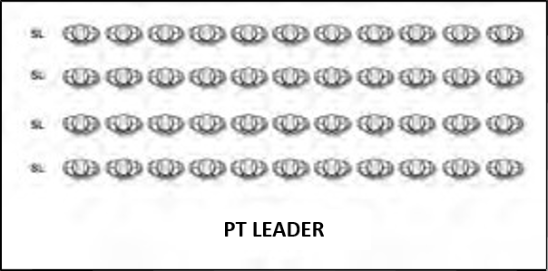

Figure 7-1. Platoon rectangular formation

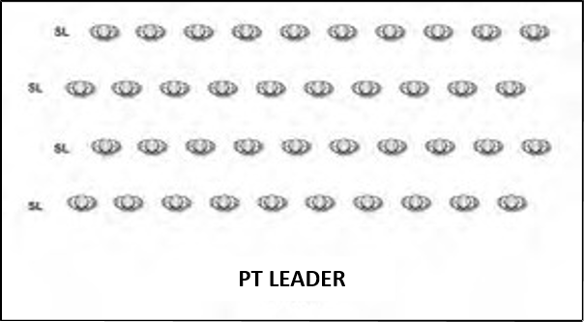

Figure 7-2. Platoon rectangular formation extended and uncovered

Platoon Reassembly

To reassemble the formation, the PT leader commands:
“Assemble to the Right, MARCH.” All cadets double-time to their original positions in the formation (Figure 7-1).

Company Formation En Masse

The PT leader will position a company-size unit in a rectangular formation. He first adjusts the base platoon so that the company will be centered and five paces away from the PT platform after they have assumed the rectangular formation (Figure 7-5). The PT leader gives the commands specified previously to extend the formation (Figure 7-6).

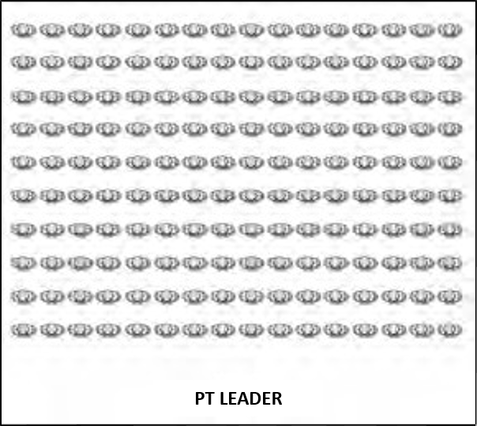

Figure 7-5. Formation of company en masse

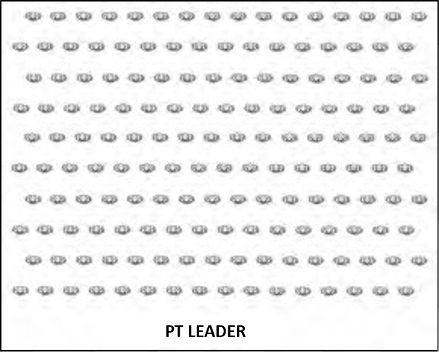

Figure 7-6. Company en masse extended and uncovered

To reassemble the formation, the PT leader commands:
“Assemble to the right, MARCH.” All Cadets double-time to their original positions in the formation (Figure 7-5).

Positions

When a set of conditioning exercises is employed, cadets assume the proper starting position of each exercise on the command “Starting Position, MOVE.” When conducting exercises, cadets are commanded to return to the position of attention from the terminating position of the exercise, before commanded to assume the starting position for the next exercise.

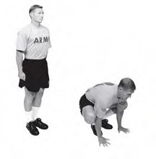
Squat Position

To assume the squat position from the position of attention, lower the body by bending the knees and place the hands with palms down and fingers spread, shoulder width in front of the body, and in between the bent legs. Raise the heels, supporting the body weight on the balls of the feet and hands. Direct the head and the eyes to a point about three to four feet in front of the body (Figure 7-9).

Figure 7-9. Squat position

Front Leaning Rest Position

The cadet assumes the front leaning rest position by performing two movements. First, the cadet moves from the position of attention to the squat position, then thrusts the feet backward to the front leaning rest position. If he has trouble with the squat thrust, he can step back with his left leg—then with his right leg—to get into the front leaning rest position. In the front leaning rest position, maintain straight body alignment from his head to his heels. He supports his body weight on his hands (shoulder width) and on the balls of his feet. He keeps his feet and legs together (Figure 7-10).

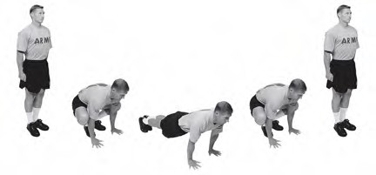

Figure 7-10. Front leaning rest position

Six-Point Stance

Assume the six-point stance by dropping to the knees from the front leaning rest position. Maintain a straight line from the head to the knees (Figure 7-11).

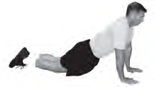

Figure 7-11. Six-point stance
Straddle Stance

Assume the straddle stance position by standing with the feet straight ahead and aligned with the shoulders (Figure 7-12).

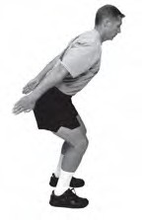
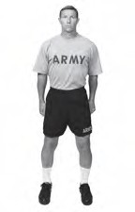

Figure 7-12. Straddle stance Figure 7-13. Forward leaning stance

Forward Leaning Stance

Assume the forward leaning stance by bending the trunk forward 45 degrees, knees bent 45 degrees, with the heels flat on the ground, and the feet aligned with the shoulders. Keep the back straight, maintaining a straight line from the head to the hips (Figure 7-13).

Prone Position

Assume the prone position by performing three movements: 1) From the position of attention, move to the squat position, 2) thrust the feet backward to the front leaning rest position, and then 3) lower the body slowly to the ground. Keep the elbows close to the body and pointed directly to the rear (Figure 7-14).

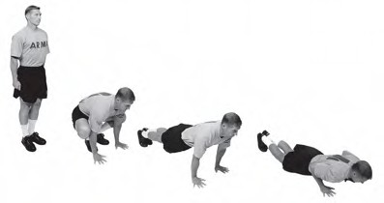

Figure 7-14. Prone position

Supine Position

To assume the supine position without using the hands, from the standing position, place one foot behind the other and slowly lower the body until the rear knee touches the ground. Sit back onto the buttocks and then lay on the back with feet and legs together (Figure 7-15). When returning to the standing position, sit up and rock forward on one knee. From this position, step up with the other leg and stand without using the hands for assistance (Figure 7-16).

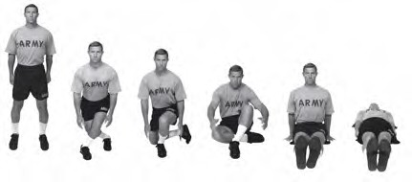
Figure 7-15. Supine position

If the cadet has difficulty assuming this position, he can place his hands on the ground as he slowly lowers his body to the seated position (Figure 7-16). If he cannot attain the standing position without using his hands, he can place them on the ground to either side of his body and push up while standing from the seated position. To return to a standing position from the supine position, he performs the actions in reverse order (Figure 7-15).

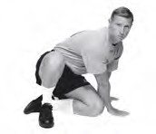

Figure 7-16. Hands down assist to supine position

Cadence

The following paragraphs discuss cadence speed and conduct of exercises.
Speed

Cadence speed is described as SLOW or MODERATE. The speed of each cadence is listed below:
- SLOW–50 counts per minute.
- MODERATE–80 counts per minute.

EXERCISE NAME

Once cadets have learned the names of the exercises, the PT leader merely needs to say the exercise name, command the cadets to assume the starting position and start them exercising to cadence. For example, this is how the PT leader begins exercise 1 of preparation, bend, and reach to cadence:
- The PT leader states, “the Bend and Reach.”
- The cadets respond, “the Bend and Reach.”
- The PT leader commands, “Starting Position, MOVE” (Cadets assume the starting position).
- The PT leader commands, “In Cadence (cadets respond, “In Cadence”), EXERCISE.”
- The command, “EXERCISE” initiates movement to the position of count 1.

The previous command sequence is also used in the conduct of preparation and recovery exercises.

Counting cadence ensures that exercises are performed at the appropriate speed. The cadence count indicates termination of movement to each position. The cumulative count is a method of indicating the number of repetitions of an exercise on the fourth count of a 4-count exercise. The use of the cumulative count is required for the following reasons:
- It provides the PT leader with an excellent method of counting the number of repetitions performed.
- It serves as motivation. Cadets like to know the number of repetitions they are expected to perform.
- It prescribes an exact amount of exercise for any group.

Counts

This paragraph describes the conduct of cadence counts:

Four-Count Exercise
- The PT leader counts, “One, two, three.”
- The cadets respond, “One.”
- The PT leader counts, “One, two, three.”
- The cadets respond, “Two.”
- The PT leader counts, “One, two, three.”
- The cadets respond, “Three,” and so forth.

Eight-Count Exercise
- The PT leader counts, “One, two, three, four, five, six, seven.”
- The cadets respond, “One.”
- The PT leader counts, “One, two, three, four, five, six, seven.”
- The cadets respond, “Two.”
- The PT leader counts, “One, two, three, four, five, six, seven.”
- The cadets respond, “Three,” and so forth.

Termination

To terminate an exercise, the PT leader will raise the inflection of his voice while counting out the cadence of the last repetition. The cadets and PT leader respond with “HALT” upon returning to the starting position.

Four-Count Exercise
- The PT leader counts, “One, two, three.”
- The cadets respond, “Nine.”
- The PT leader counts, “One, two, three” (with voice inflection).
- The cadets and PT leader respond, “HALT.”
- The PT leader commands “Position of attention, MOVE.”
- The cadets assume the position of attention.

Eight-Count Exercise
- The PT leader counts, “One, two, three, four, five, six, seven.”
- The cadets respond, “Four.”
- The PT leader counts, “One, two, three, four, five, six, seven” (with voice inflection on counts five, six, and seven).
- The cadets and PT leader respond, “HALT.”
- The PT leader commands, “Position of attention, MOVE.”
- The cadets assume the position of attention.

Commands

The Preparation Drill (PD) consists of ten four-count callisthenic exercises. See the previous paragraph for the commands, counting, and cadence instructions used to conduct preparation.

Conditioning Drills

Conditioning drills have four-count and eight-count exercises.

Running Activities

Running activities have different sets of commands. Sustained running begins when the PT leader states, “Double time, MARCH,” and terminates the run with the commands, “Quick Time, MARCH.”

When conducting 30:60s or 60:120s, the PT leader begins the activity with slow jogging for ¼-mile on the commands of “Double Time, MARCH,” and terminates the ¼-mile run with the commands, “Quick Time, MARCH.” 30:60s and 60:120s begin with the PT leader signaling the start of each work interval (30 or 60 seconds) with one short whistle blast. Two short whistle blasts are used to signal the end of each work interval and the start of the rest intervals (60 or 120 seconds). Upon completion of the scheduled number of repetitions of 30:60s or 60:120s, the PT leader will command the formation to continue to walk for at least three minutes before performing additional activities or the Recovery Drill (RD).

RECOVERY DRILL

The RD exercises require no verbal cadence. Cadets move in and out of the starting position and each exercise position on the PT leader’s commands. Cadets hold each exercise position for 20 seconds during recovery. The leader does not count the seconds aloud. This is how he conducts recovery exercise 1, overhead arm pull:
- The PT leader commands, “THE OVERHEAD ARM PULL.” Each cadet responds, “THE OVERHEAD ARM PULL.”
- The PT leader commands, “Starting Position, MOVE.” Each cadet moves into the starting position, straddle stance with hands on hips.
- The command to begin the stretch is, “Ready, STRETCH.” Each cadet raises his left arm overhead and places his left hand behind his head and grasps above his left elbow with his right hand. He then pulls to the right, leaning his body to the right. He holds this position for 20 seconds.
- The PT leader commands, “Starting Position, MOVE.” Each cadet moves into the starting position.
- The PT leader gives the command to stretch the other side of the body: “Change Position, Ready, STRETCH.” Each cadet raises his right arm overhead and places his right hand behind his head and grasps above his right elbow with his left hand. He then pulls to his left, leaning his body to the left. He holds this position for 20 seconds.
- The PT leader commands, “Starting Position, MOVE.” Each cadet assumes the starting position.
- The PT leader assumes the position of attention and commands, “Position of Attention, MOVE.” Each cadet assumes the position of attention.

Mirror Effect

When leading an exercise in front of the formation, the PT leader begins the movements in count 1 to the right. He continues to mirror the cadet’s movements while facing them throughout the exercise.

Summary
Successful execution of PT depends on the leadership of competent instructors and AIs. PT leaders must have more than the knowledge, skills, and abilities to execute a PT session. They must also present a positive image of physical fitness.

A3. PREPARATION DRILL (PD)

Preparation

The purpose of preparation is to ready the cadet for PT activities. The PD is performed at the beginning of every PT session. The PD consists of ten exercises performed for 5-10 repetitions at a slow cadence, with the exception of the high jumper and push-up (which are performed at a moderate cadence). When conducted to standard, preparation will last about 15 minutes. Since PT sessions are generally limited to one hour or less, preparation must be brief, yet thorough. The objectives of preparation are to:
- Increase body temperature and heart rate.
- Increase pliability of joints and muscles.
- Increase responsiveness of nerves and muscles.

Training Area

Any dry, level area of adequate size is satisfactory for conducting the PD.

Uniform

Cadets should wear a PT uniform, or loose-fitting clothing that allows sweat to dissipate.

Formation

The extended rectangular formation is prescribed for the conduct of the PD.

Leadership

A PT leader and AI are required to lead the PD.

Instruction and Execution

The PT leader must be familiar with the method of teaching these exercises, the commands, the formations, and the use of AIs as described in Lesson A2, Execution of Training. The callisthenic exercises that comprise the PD are always given in cadence. Cadets begin and terminate each exercise at the starting position, then move to the position of attention. The goal is to complete the entire drill with only enough pauses between exercises for the PT leader to indicate the next one by name. This continuous method of conducting the PD intensifies the workload and conserves time. Cadets should memorize the exercises by name and movement.

Precision

Preparation loses much of its value unless performed exactly as prescribed. During preparation, the focus is always on quality of movement, not quantity of repetitions or speed of movement. A callisthenic cadence that is too fast will not allow cadets to achieve a full range of movement and may not adequately prepare them for the activities that follow. Assistant instructors will help to maintain the ranks at the appropriate pace and offer feedback on form.

Progression

Preparation is always performed in all phases of PT. When cadets are in fairly poor shape, the PD consists of 5 repetitions of 10 exercises performed at a slow cadence, with the exception of the high jumper and the push-up, which are performed at a moderate cadence. Once cadets are in better physical condition, they progress from performing 5 repetitions to 10 repetitions of each exercise in the PD.

Integration

Preparation not only prepares the body for activities that follow; it also integrates the components of strength, endurance, and mobility.

Commands

The commands used to conduct preparation are described in Lesson A2, Execution of Training.

PREPARATION DRILL

Table 8-1 lists the 10 callisthenic exercises that comprise the PD. These 10 exercises are always performed in the order and at the cadence shown.

Table 8-1. Preparation drill

1. Bend and Reach | 5-10 repetitions, slow
2. Rear lunge | 5-10 repetitions, slow
3. High jumper | 5-10 repetitions, moderate
4. Rower | 5-10 repetitions, slow
5. Squat bender | 5-10 repetitions, slow
6. Windmill | 5-10 repetitions, slow
7. Forward lunge | 5-10 repetitions, slow
8. Prone row | 5-10 repetitions, slow
9. Bent-leg body twist | 5-10 repetitions, slow
10. Push-up | 5-10 repetitions, moderate

Table 8-2 shows the body segments trained during the PD.

Table 8-2. Body segments trained in the conduct of the preparation drill

PREPARATION DRILL (PD) | MUSCLES
 | HIPS | THIGHS | LOWER LEGS | CHEST | BACK | TRUNK | SHOULDERS | ARMS
1. BEND AND REACH | X | X |  |  | X | X | X
2. REAR LUNGE | X | X | X |  | X | X
3. HIGH JUMPER | X | X | X |  | X | X | X
4. ROWER | X | X | X |  | X | X | X | X
5. SQUAT BENDER | X | X | X | X | X | X | X | X
6. WINDMILL | X | X | X | X | X | X | X | X
7. FORWARD LUNGE | X | X | X |  | X | X
8. PRONE ROW | X |  |  | X | X | X | X | X
9. BENT-LEG BODY TWIST | X | X |  |  | X | X
10. PUSH-UP | X | X | X | X | X | X | X | X

EXERCISE 1: Bend and Reach

Purpose: This exercise develops the ability to squat and reach through the legs. It also serves to prepare the spine and extremities for more vigorous movements, moving the hips and spine through full flexion (Figure 8-1).

Starting Position: Straddle stance with arms overhead, palms facing inward, fingers and thumbs extended and joined.

Cadence: SLOW

Count:
1. Squat with the heels flat as the spine rounds forward to allow the straight arms to reach as far as possible between the legs.
2. Return to the starting position.
3. Repeat count one.
4. Return to the starting position.

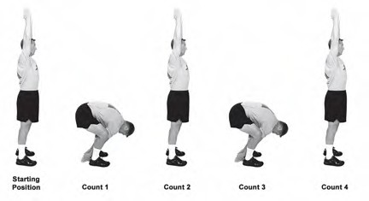

Check Points:
Figure 8-1. Bend and reach
- From the starting position, ensure that cadets have their hips set, their abdominals tight, and their arms fully extended overhead.
- The neck flexes to allow the gaze to the rear. This brings the head in line with the bend of the trunk.
- The heels and feet remain flat on the ground.
- On counts 2 and 4, do not go past the starting position.

Precautions: This exercise is always performed at a slow cadence. To protect the back, move into the count one position in a slow, controlled manner. Do not bounce into or out of this position in a ballistic manner, as this may place an excessive load on the back.
EXERCISE 2: Rear Lunge

Purpose: This exercise promotes balance, opens up the hip and trunk on the side of the lunge, and develops leg strength (Figure 8-2).

Starting Position: Straddle stance with hands on hips.

Cadence: SLOW

Count:

1. Take an exaggerated step backward with the left leg, touching down with the ball of the foot.
2. Return to the starting position.
3. Repeat count one with the right leg.
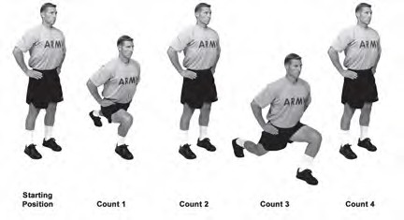
4. Return to the starting position.

Check Points:
Figure 8-2. Rear lunge
- Maintain straightness of the back by keeping the abdominal muscles tight throughout the motion.
- After the foot touches down, allow the body to continue to lower. This promotes flexibility of the hip and trunk.
- On counts 1 and 3, step straight to the rear, keeping the feet directed forward. When viewed from the front, the feet maintain their distance apart both at the starting position and at the end of counts 1 and 3.
- Keep the rear leg as straight as possible but not locked and the rear heel off the ground.

Precautions: This exercise is always performed at a slow cadence. On counts 1 and 3, move into position in a slow, controlled manner. If the cadence is too fast, it will be difficult to go through a full range of motion.
EXERCISE 3: High Jumper

Purpose: This exercise reinforces correct jumping and landing, stimulates balance and coordination, and develops explosive strength (Figure 8-3).

Starting Position: Forward leaning stance, palms facing inward, fingers and thumbs extended and joined.

Cadence: MODERATE

Count:

1. Swing arms forward and jump a few inches.
2. Swing arms backward and jump a few inches.
3. Swing arms forward and vigorously overhead while jumping forcefully.
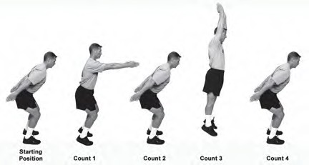
4. Repeat count 2. On the last repetition, return to the starting position.

Check Points:
Figure 8-3. High jumper
- At the starting position, the shoulders, the knees, and the balls of the feet should form a straight vertical line.
- On count 1, the arms are parallel to the ground.
- On count 3, the arms should be extended fully overhead. The trunk and legs should also be aligned.
- The cadet is jumping on each count. On counts 1, 2, and 4, the jumps are only 4-6 inches off the ground. On count 3, the cadet jumps higher (6-10 inches) while maintaining the posture pictured in Figure 8-3.
- On each landing, the feet should be directed forward and maintained at shoulder distance apart. The landing should be “soft” and proceed from the balls of the feet to the heels. The vertical line from the shoulders through the knees to the balls of the feet should be demonstrated on each landing.
EXERCISE 4: Rower

Purpose: This exercise improves the ability to move in and out of the supine position to a seated posture. It coordinates the action of the trunk and extremities while challenging the abdominal muscles (Figure 8-4).

Starting Position: Supine position, arms overhead, feet together and pointing upward. The chin is tucked and the head is 1-2 inches above the ground. Arms are shoulder-width, palms facing inward with fingers and thumbs extended and joined.

Cadence: SLOW

Count:

1. Sit up while swinging arms forward and bending at the hip and knees. At the end of the motion, the arms will be parallel to the ground with palms facing inward.
2. Return to the starting position.
3. Repeat count 1.
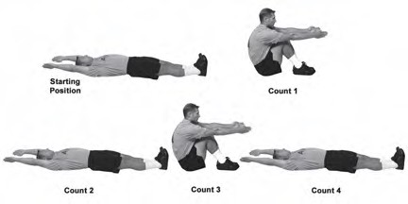
4. Return to the starting position.

Check Points:
Figure 8-4. Rower
- At the starting position, the low back must not be arched excessively off the ground. To prevent this, tighten the abdominal muscles to tilt the pelvis and low back toward the ground.
- At the end of counts 1 and 3, the feet are flat and pulled near the buttocks. The legs stay together throughout the exercise and the arms are parallel to the ground.

Precautions: This exercise is always performed at a slow cadence. Do not arch the back to assume counts 1 and 3.
EXERCISE 5: Squat Bender

Purpose: This exercise develops strength, endurance, and flexibility of the lower back and lower extremities (Figure 8-5).

Starting Position: Straddle stance with hands on hips.

Cadence: SLOW

Count:

1. Squat while leaning slightly forward at the waist with the head up and extend the arms to the front, with arms parallel to the ground and palms facing inward.
2. Return to the starting position.
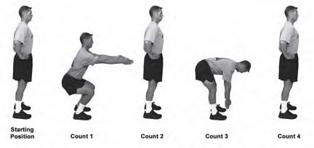
3. Bend forward and reach toward the ground with both arms extended and palms inward.
4. Return to the starting position.

Check Points:
Figure 8-5. Squat bender
- At the end of count 1, the shoulders, knees, and the balls of the feet should be aligned. The heels remain on the ground and the back is straight.
- On count 3, bend forward, keeping the head aligned with the spine and the knees slightly bent.
- Attempt to keep the back flat and parallel to the ground.

Precaution: This exercise is always performed at a slow cadence. Allowing the knees to go beyond the toes on count 1 increases stress to the knees.
EXERCISE 6: Windmill

Purpose: This exercise develops the ability to safely bend and rotate the trunk. It conditions the muscles of the trunk, legs, and shoulders (Figure 8-6).

Starting Position: Straddle stance with arms sideward, palms facing down, fingers and thumbs extended and joined.

Cadence: SLOW

Count:
1. Bend the hips and knees while rotating to the left. Reach down and touch the outside of the left foot with the right hand and look toward the rear. The left arm is pulled rearward to maintain a straight line with the right arm.
2. Return to the starting position.
3. Repeat count 1 to the right.
4. Return to the starting position.
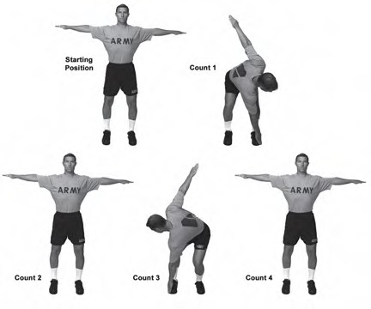

Figure 8-6. Windmill
Check Points:
- From the starting position, feet are straight ahead, arms parallel to the ground, hips set, and abdominals tight.
- On counts 1 and 3, ensure that both knees bend during the rotation. Head and eyes are directed to the rear on counts 1 and 3.

Precaution: This exercise is always performed at a slow cadence.
EXERCISE 7: Forward Lunge

Purpose: This exercise promotes balance and develops leg strength (Figure 8-7).

Starting Position: Straddle stance with hands on hips.

Cadence: SLOW

Count:
1. Take a step forward with the left leg (the left heel should be 3 to 6 inches forward of the right foot). Lunge forward, lowering the body and allow the left knee to bend until the thigh is parallel to the ground. Lean slightly forward, keeping the back straight.
2. Return to the starting position.
3. Repeat count one with the right leg.
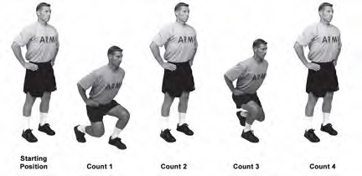
4. Return to the starting position.

Check Points:
Figure 8-7. Forward lunge
- Keep the abdominal muscles tight throughout the motion.
- On counts 1 and 3, step straight forward, keeping the feet directed forward. When viewed from the front, the feet maintain their distance apart both at the starting position and at the end of counts 1 and 3.
- On counts 1 and 3, the rear knee bends, but does not touch the ground. The heel of the rear foot should be off the ground.

Precautions: This exercise is always performed at a slow cadence. On counts 1 and 3, move into position in a controlled manner. Spring off of the forward leg to return to the starting position. This avoids jerking the trunk to create momentum.
EXERCISE 8: Prone Row

Purpose: This exercise develops strength of the back and shoulders (Figure 8-8).

Starting Position: Prone position with the arms overhead, palms down, fingers and thumbs extended and joined, 1 to 2 inches off the ground and toes pointed to the rear.

Cadence: SLOW

Count:
1. Raise the head and chest slightly while lifting the arms and pulling them rearward. Hands make fists as they move toward the shoulders.
2. Return to the starting position.
3. Repeat count 1.
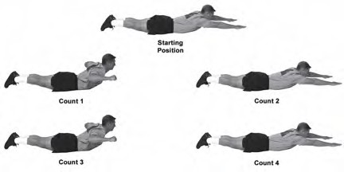
4. Return to the starting position.

Check Points:
Figure 8-8. Prone row
- At the starting position, the abdominal muscles are tight and the head is aligned with the spine.
- On counts 1 and 3, the forearms are parallel to the ground and slightly higher than the trunk.
- On counts 1 and 3, the head is raised to look forward but not skyward.
- Throughout the exercise, the legs and toes remain in contact with the ground.

Precautions: This exercise is always performed at a slow cadence. Prevent overarching of the back by maintaining contractions of the abdominal and buttocks muscles throughout the exercise.
EXERCISE 9: Bent-Leg Body Twist

Purpose: This exercise strengthens trunk muscles and promotes control of trunk rotation (Figure 8-9).

Starting Position: Supine position with the hips and knees bent to 90-degrees, arms sideward and palms down. The knees and feet are together.

Cadence: SLOW

Count:
1. Rotate the legs to the left while keeping the upper back and arms in place.
2. Return to the starting position.
3. Repeat count 1 to the right.
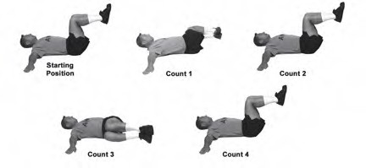
4. Return to the starting position.

Check Points:
Figure 8-9. Bent-leg body twist
- Tighten the abdominal muscles in the starting position and maintain this contraction throughout the exercise.
- The head should be off the ground with the chin slightly tucked.
- Ensure that the hips and knees maintain 90-degree angles.
- Keep the feet and knees together throughout the exercise.
- Attempt to rotate the legs to about 8 to 10 inches off the ground. The opposite shoulder must remain in contact with the ground.

Precautions: This exercise is always performed at a slow cadence. Do not rotate the legs to a point beyond which the opposite arm and shoulder can no longer maintain contact with the ground.
EXERCISE 10: Push-Up

Purpose: This exercise strengthens the muscles of the chest, shoulders, arms, and trunk (Figure 8-10).

Starting Position: Front leaning rest position.

Cadence: MODERATE

Count:
1. Bend the elbows, lowering the body until the upper arms are parallel with the ground.
2. Return to the starting position.
3. Repeat count 1.
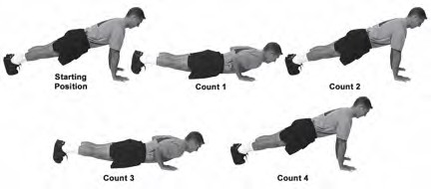
4. Return to the starting position.

Figure 8-10. Push-up

Check Points:

- The hands are directly below the shoulders with fingers spread (middle fingers point straight ahead).
- On counts 1 and 3, the upper arms stay close to the trunk, elbows pointing rearward.
- On counts 2 and 4, the elbows straighten but do not lock.
- To prevent the trunk from sagging, tighten the abdominal muscles while in the starting position and maintain this contraction throughout the exercise.

EXERCISE 10A: Push-Up Using Six-Point Stance

Purpose: Cadets should assume the six-point stance on their knees, when unable to perform repetitions correctly to cadence (Figure 8-11).

Figure 8-11. Push-up using the six-point stance

A4. ACTIVITIES

After conducting the Preparation Drill, the unit conducts an activity – usually some type of cardiovascular activity, like running, circuit training, grass drills, or sports. We discuss a few of these here, but you are not limited to what is in this lesson. Making PT interesting by doing different activities not only keeps cadets’ interest in the program, but exercises different muscles.

RUNNING

The purpose of running is to improve the overall conditioning of the cadet by developing endurance. Endurance spans a continuum between aerobic and anaerobic systems. Aerobic endurance is developed by performing low to moderate intensity activities for a long duration. Anaerobic endurance is developed by performing high-intensity activities for a short duration, resting, and then repeating the sequence. Developing strength requires anaerobic exercise. In order to train the complete spectrum of endurance, speed running, sustained running, and foot movement under load must be performed. Running activities described here may be performed individually or collectively.

Running can be conducted over a variety of terrain – roads, fields, tracks, wooded areas, or hills. For cadets, it is best to stay on roads. Running on various terrain helps cadets prepare for what is required in combat, but the likelihood of foot and ankle injuries is greatly increased. The risk outweighs the benefits of running over a variety of terrain.

Form

Running form varies from cadet to cadet. Anatomical variations cause a variety of biomechanical manifestations. Many individual variations may be successful. Attempts to force cadets to conform to one standard may do more harm than good; however, there are some basic guidelines that may improve running efficiency without overhauling the natural stride. Generally, the form and technique for all types of running is fairly constant. The following information addresses optimal running form for the major body segments (Figure 10-2).

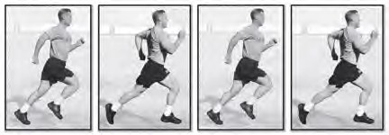

Figure 10-2. Sustained running form

Head

The head should be held high, with the chin pointed forward, neither up nor down. Allowing the head to ride forward puts undue strain on the muscles of the upper back.
Shoulders

The shoulders should assume a neutral posture, neither rounded forward nor forcefully arched backward. Rounding the shoulders forward is the most common fault in everyday posture while walking and running. The problem is usually associated with tightness of the chest and shoulder muscles. Another problem occurs when the shoulders start to rise with fatigue or increased effort. This position not only wastes energy, but can also adversely affect breathing.

Arms

Throughout the arm swing, the elbows should stay at roughly a 90-degree bend. The wrists stay straight and the hands remain loosely cupped. The arm swing should be free of tension, but do not allow the hands to cross the midline of the body.

Trunk and Pelvis

The trunk should remain over its base of support, the pelvis. A common problem with fatigue is allowing the trunk to lean forward of the legs and pelvis. This forces the lower back muscles to expend too much energy resisting further trunk lean to the front.

Legs

For distance running, much of the power is generated from below the knee. Energy is wasted as the knees come higher and the large muscles of the hips and thighs are engaged. Practice getting a strong push-off from the ankle of the back leg. This helps to lengthen the stride naturally. Lengthening the stride by reaching forward with the front leg will be counterproductive.

Feet

The feet should be pointed directly forward while running. With fatigue and certain muscle imbalances, the legs and feet may start to rotate outward. This may hinder performance and create abnormal stresses that contribute to injury.

Breathing

Breathing should be rhythmic in nature and coordinated with the running stride.

TYPES OF RUNS:
Ability Group Run

The Ability Group Run (AGR) trains cadets in groups of near-equal ability. Each ability group runs at a prescribed pace intense enough to produce a training effect for that group and each cadet in it. Leaders should program these runs for specific lengths of time, not miles to be run. This training method provides a challenge for each ability group while controlling injuries. The PT leader conducts a 1-mile run assessment to assign cadets in ability groups. Based on each Cadet’s 1-mile run assessment time, the PT leader assigns the cadet to one of the groups shown in Table 10-3.

Table 10-3. Sample Ability Group Assignment

A Group: 7:15 and faster
B Group: 7:16 to 8:15
C Group: 8:16 to 10:15
D Group: 10:16 and slower

Some cadets may make the cut off times to qualify for an ability group but are unable to maintain the prescribed running pace listed in the PT schedule. If this occurs, they may drop down to the slower group and progress later to the faster running group. Ability group runs, speed running, and foot marching (greater than 5 km) should not be conducted on the same or consecutive days. The running duration is determined by time, not distance. Cadets should move to faster groups when they are ready because they progress at different rates. Those who have difficulty maintaining the specified pace within an ability group should be placed in a slower ability group. Supervision will prevent a constant shifting of cadets between groups due to lack of individual effort. Routes used for sustained running in ability groups should be well lighted, free from hazards and traffic, and marked at ¼-mile intervals. Ability group leaders will ensure running is at the proper pace prescribed for their group by checking their split times at each ¼-mile marker along the route. Table 10-4 shows the appropriate ¼-mile split time based on the AGR pace.

Table 10-4. Quarter-mile split times based on AGR pace

 | Pace/Mile |  | 1/4-Mile  Split |  | Pace/Mile |  | 1/4-Mile  Split |  | Pace/Mile |  | 1/4-Mile  Split
6:00  6:15  6:30  6:45  7:00  7:15  7:30  7:45  8:00 |  | 1:30  1:34  1:37  1:42  1:45  1:48  1:52  1:56  2:00 |  | 8:15  8:30  8:45  9:00  9:15  9:30  9:45  10:00  10:15 |  | 2:03  2:07  2:11  2:15  2:19  2:23  2:27  2:30  2:34 |  | 10:30  10:45  11:00  11:15  11:30  11:45  12:00  12:15  12:30 |  | 2:38  2:42  2:45  2:49  2:53  2:57  3:00  3:04  3:07

Unit Formation Run

The unit formation run elicits intangible rewards gained from running with a group, such as esprit de corps, team building, and discipline. Unit formation runs are based on a time and/or distance that can be achieved with unit integrity and a display of unit cohesion. Unit formation runs are organized by squad, platoon, company, or battalion; not by ability. Keeping a large unit in step, with proper distance intervals and correct running form, offers intangible benefits that commanders desire. Commanders should not use unit formation runs as the foundation of their PT program. They should be performed no more than once per month due to the limited training effect offered for the entire unit. The unit formation run begins with a gradual increase in intensity for the first three minutes or ¼ mile, then continues at a prescribed target pace for a specified time, and concludes with a gradual decrease in intensity for the last three minutes or ¼ mile. The gradual increase and gradual decrease quarter miles will be conducted at a pace two minutes slower than the target pace. The unit commander is responsible for establishing a pace achievable by all cadets in the unit.

Release Run

The release run combines the benefits of formation running and individual performance at higher training intensities. Cadets will run in formation for a specified time (no more than 10 minutes), then released to run as fast as they can back to the starting point. Upon completion of the release run, additional PT activities may be conducted or recovery performed.

Last Man Up Run

The last man up run combines sprinting with longer distance running. It is usually done with a relatively small group of 20 cadets or less. The unit forms in a single file and the run is conducted much like a unit formation run. After the unit has been running for a couple of minutes, the PT Leader indicates by a command (“Go” works well) that the last cadet in line is to sprint up to the front of the formation. That cadet then falls into the first position in the file. The PT Leader, at his discretion, then commands the cadet who is now last in the file to Go, and he sprints to the front and falls into the front position. This continues throughout the run.

CIRCUIT TRAINING

Circuits

A circuit is a group of stations or areas where specific tasks or exercises are performed. The task or exercise selected for each station and the arrangement of the stations is determined by the objective of the circuit. Circuits are designed to provide exercise to groups of cadets at intensities which suit each person’s fitness level. Circuits can promote fitness in a broad range of physical and motor fitness areas. These include cardiorespiratory endurance, muscular endurance, strength, flexibility, and speed. Circuits can also be designed to concentrate on sports skills. In addition, circuits can be organized to exercise all the fitness components in a short period of time. A little imagination can make circuit training an excellent addition to a unit’s total physical fitness program. At the same time, it can provide both fun and a challenge to cadets’ physical and mental abilities. Almost any area can be used, and any number of cadets can exercise for various lengths of time.

Types of Circuits

The two basic types of circuits are the free circuit and the fixed circuit. Each has distinct advantages.

Free Circuit
In a free circuit, there is no set time for staying at each station, and no signal is given to move from one station to the next. Cadets work at their own pace, doing a fixed number of repetitions at each station. Progress is measured by the time needed to complete a circuit. Because cadets may do incomplete or fewer repetitions than called for to reduce this time, the quality and number of the repetitions done should be monitored. Aside from this, the free circuit requires little supervision.

Fixed Circuit

In a fixed circuit, a specific length of time is set for each station. The time is monitored with a stopwatch, and cadets rotate through the stations on command. There are three basic ways to increase the intensity or difficulty of a fixed circuit:

• Keep the time for completion the same, but increase the number of repetitions.
• Increase the time per station along with the number of repetitions.
• Increase the number of times cadets go through the circuit.

Variables in Circuit Training

Several variables in circuit training must be considered. These include the time, number of stations, number of stations, number of cadets, number of times the circuit is completed, and sequence of stations. These are discussed below.

Time

One of the first things to consider is how long it should take to complete the circuit. When a fixed circuit is run, the time at each station should always be the same to avoid confusion and help maintain control. Consider also the time it takes to move from one station to the next. Further, allow from five to seven minutes both before and after running a circuit for warming up and cooling down, respectively.

Number of Stations

The objective of the circuit and time and equipment available strongly influence the number of stations. A circuit geared for a limited objective (for example, developing lower-body strength) needs as few as six to eight stations. On the other hand, circuits to develop both strength and cardiorespiratory fitness may have as many as 20 stations.

Number of Cadets

If there are 10 stations and 40 cadets to be trained, the cadets should be divided into 10 groups of four each. Each station must then be equipped to handle four cadets. For example, in this instance a rope jumping station must have at least four jump ropes. It is vital in a free circuit that no cadet stand around waiting for equipment. Having enough equipment reduces bottlenecks, slowdowns, and poor results.

Number of Times a Circuit is Completed

To achieve the desired training effect, cadets may have to repeat the same circuit several times. For example, a circuit may have ten stations. cadets may run through the circuit three times, exercising for 30 seconds at each station, and taking 15 seconds to move between stations. The exercise time at each station may be reduced to 20 seconds the second and third time through. The whole workout takes less than 45 minutes including warm-up and cool-down. As cadets become better conditioned, exercise periods may be increased to 30 seconds or longer for all three rotations. Another option is to have four rotations of the circuit.

Sequence of Stations

Stations should be arranged in a sequence that allows Cadets some recovery time after exercising at strenuous stations. Difficult exercises can be alternated with less difficult ones. After the warm-up, Cadets can start a circuit at any station and still achieve the objective by completing the full circuit.

DESIGNING A CIRCUIT

The designer of a circuit must consider many factors. The six steps below cover the most important aspects of circuit development.

Determine Objectives

The designer must consider the specific parts of the body and the components of fitness on which Cadets need to concentrate. For example, increasing muscular strength may be the primary objective, while muscular endurance work may be secondary. On the other hand, improving cardiorespiratory endurance may be the top priority. The designer must first identify the training objectives in order to choose the appropriate exercises.

Select the Activities

The circuit designer should list all the exercises or activities that can help meet the objectives. Then he should look at each item on the list and ask the following questions:

● Will equipment be needed? Is it available?
● Will supervision be needed? Is it available?
● Are there safety factors to consider?

Answering these questions helps the designer decide which exercises to use. He can choose from the exercises, calisthenics, conditioning drills, and grass drills. However, he should not limit the circuit to only these activities. Imagination and field expediency are important elements in developing circuits that hold the interest of Cadets. (Figures 7-1 through 7-3.)

Arrange the Stations

A circuit usually has 8 to 12 stations, but it may have as many as 20. After deciding how many stations to include, the designer must decide how to arrange them. For example, in a circuit for strength training, the same muscle group should not be exercised at consecutive stations. One approach is to alternate “pushing” exercises with “pulling” exercises which involve movement at the same joint(s). For example, in a strength training circuit, exercisers may follow the pushing motion of a bench press with the pulling motion of the seated row. This could be followed by the pushing motion of the overhead press which could be followed by the pulling motion of the Flat pull-down. Another approach might be to alternate between upper and lower body exercises. By not exercising the same muscle group twice in a row, each muscle has a chance to recover before it is used in another exercise. If some exercises are harder than others, cadets can alternate hard exercises with easier ones. The choice of exercises depends on the objectives of the circuit.

Select the Training Sites

Circuits may be conducted outdoors or indoors. If the designer wants to include running or jogging a certain distance between stations, he may do this in several ways. In the gymnasium, adets may run five laps or for 20 to 40 seconds between stations. Outdoors, they may run laps or run between spread-out stations if space is available. However, spreading the stations too far apart may cause problems with control and supervision.

Prepare a Sketch

The designer should draw a simple sketch that shows the location of each station in the training area. The sketch should include the activity and length of time at each station, the number of stations, and all other useful information.

Lay Out the Stations

The final step is to lay out the stations which should be numbered and clearly marked by signs or cards. In some cases, instructions for the stations are written on the signs. The necessary equipment is placed at each station.

Sample Conditioning Circuits

Figures 7-1, 7-2, and 7-3 show different types of conditioning circuits. Cadets should work at each station 45 seconds and have 15 seconds to rotate to the next station the circuit.

Figure 7-1. Sample Circuit for Strength Development

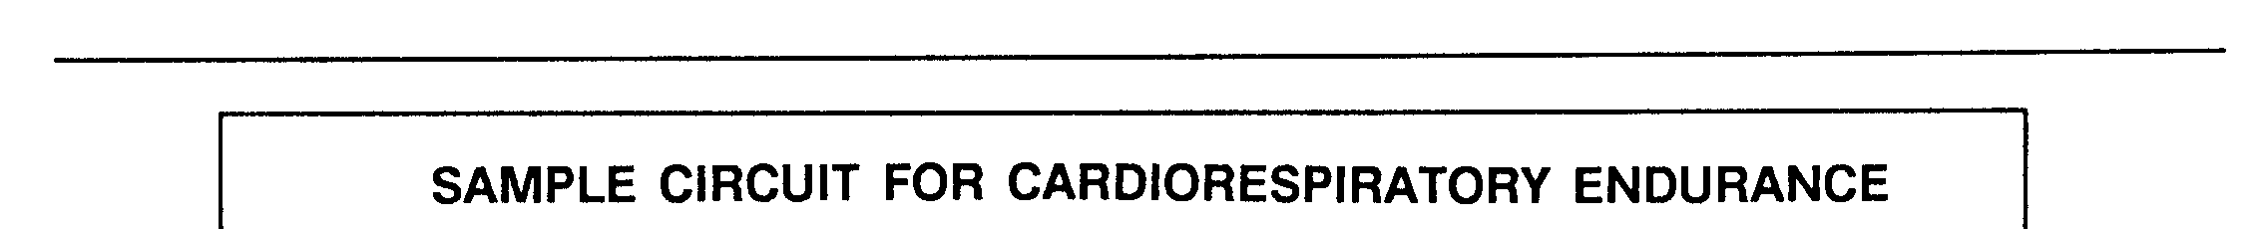

Figure 7-3. Sample Circuit for Push-Up and Sit-up Improvement

GRASS DRILLS

Grass Drills

Grass drills are exercise movements that feature rapid changes in body position. These are vigorous drills which, when properly done, exercise all the major muscle groups. Cadets should respond to commands as fast as possible and do all movements at top speed. They continue to do multiple repetitions of each exercise until the next command is given. No cadence is counted. Performing grass drills can improve CR endurance, help develop muscular endurance and strength, and speed up reaction time. Since these drills are extremely strenuous, they should last for short periods (30 to 45 seconds per exercise). The two drills described here each have four exercises. Leaders can develop additional drills locally.

The cadets should do a warm-up before performing the drills and do a cool-down afterward. The instructor does all the activities so that he can gauge the intensity of the session. The commands for grass drills are given in rapid succession without the usual preparatory commands. To prevent confusion, commands are given sharply to distinguish them from comments or words of Encouragement. As soon as the cadets are familiar with the drill, they do all the exercises as vigorously and rapidly as possible, and they do each exercise until the next command is given. Anything less than a top-speed performance decreases the effectiveness of the drills. Once the drills start, cadets do not have to resume the position of attention. The instructor uses the command “Up” to halt the drill for instructions or rest. At this command, cadets assume a relaxed, standing position. Grass drills can be done in a short time. For example, they may be used when only a few minutes are available for exercise or when combined with another activity. Sometimes, if time is limited, they are a good substitute for running. Most movements are done in place. The extended-rectangular formation is best for a platoon- or company-sized unit. The circle formation is more suitable for squad- or section-sized groups. When cadets are starting an exercise program, a 10- to 15-minute workout may be appropriate. Progression is made by a gradual increase in the time devoted to the drills. As the fitness of the cadets improves, the times should be gradually lengthened to 20 minutes. The second drill is harder than the first. Therefore, as cadets progress in the first drill, the instructor should introduce the second. If he sees that the drill needs to be longer, he can repeat the exercises or combine the two drills.

Starting Positions

After the warm-up, bring the cadets to a position of ATTENTION. The drills begin with the command
GO. Other basic commands are FRONT, BACK, and STOP. (See Figure 7-5 for the positions and actions associated with these commands.)

- ATTENTION: The position of attention is described in FM 22-5, Drill and Ceremonies.
- GO: This involves running in place at top speed on the balls of the feet. The cadet raises his knees high, pumps his arms, and bends forward slightly at the waist.
- FRONT: The cadet lies prone with elbows bent and palms directly under the shoulders as in the down position of the push up. The legs are straight and together with the head toward the instructor.
- BACK: The cadet lies flat on his back with his arms extended along his sides and his palms facing downward. His legs are straight and together; his feet face the instructor.
- STOP The cadet assumes the stance of a football lineman with feet spread and staggered. His left arm is across his left thigh; his right arm is straight. His knuckles are on the ground; his head is up, and his back is roughly parallel to the ground.

To assume the FRONT or BACK position from the standing GO or STOP positions, the cadet changes positions vigorously and rapidly. (See Figure 7-5.)

To change from the FRONT to the BACK position (Figure 7-5), the cadet does the following:

- Takes several short steps to the right or left.
- Lifts his arm on the side toward which his feet move.
- Thrusts his legs vigorously to the front.

To change from the BACK to the FRONT position, the cadet sits up quickly. He places both hands on the
ground to the right or left of his legs. He takes several short steps to the rear on the side opposite his hands. When his feet are opposite his hands, he thrusts his legs vigorously to the rear and lowers his body to the ground. (See Figure 7-5.)

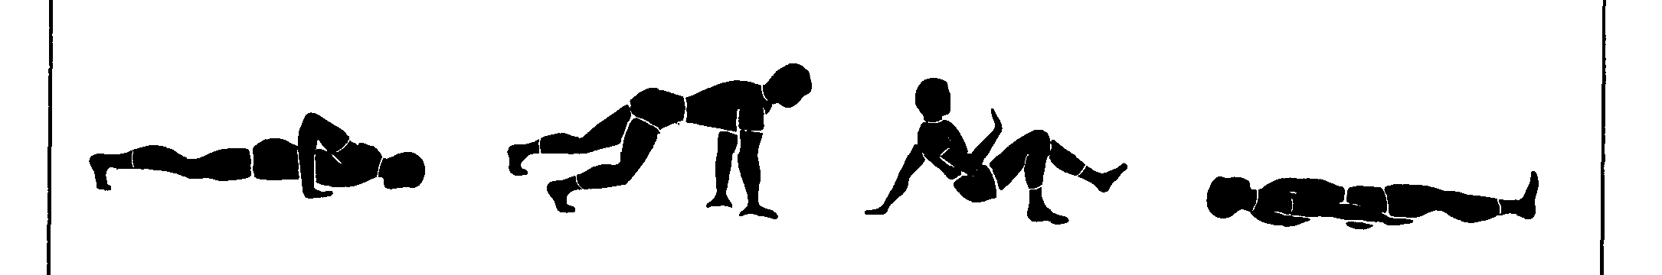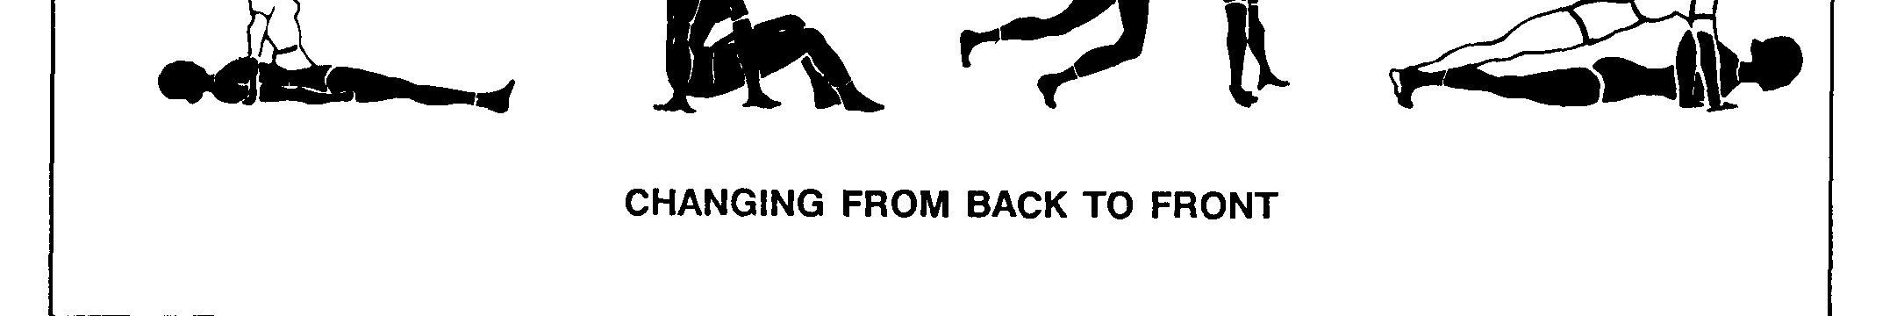
Figure 7-5. Starting Positions for Grass Drills

GRASS DRILL ONE: Exercises for grass drill are described below and shown in Figure 7-6.

Bouncing Ball

From the FRONT position, push up and support the body on the hands (shoulder-width apart) and feet. Keep the back and legs generally in line and the knees straight. Bounce up and down in a series of short, simultaneous, upward springs from the hands, hips, and feet.

Supine Bicycle

From the BACK position, flex the hips and knees. Place the palms directly on top of the head, and interlace the fingers. Bring the knee of one leg upward toward the chest. At the same time, curl the trunk and head upward while touching the opposite elbow to the elevated knee. Repeat with the other leg and elbow. Continue these movements as opposite legs and arms take turns.

Knee Bender

From the position of ATTENTION, do half-knee bends with the feet in line and the hands at the sides. Make sure the knees do not bend to an angle less than 90 degrees. Roll Left and Right from the FRONT position, continue to roll in the direction commanded until another command is given. Then, return to the FRONT position.

GRASS DRILL TWO: Exercises for grass drill two are described below and shown in Figure 7-6.

The Swimmer

From the FRONT position, extend the arms forward. Move the right arm and left leg up and down; then, move the left arm and right leg up and down. Continue in an alternating manner.

Bounce and Clap Hands

The procedure is almost the same as for the bouncing ball in grass drill one. However, while in the air, clap the hands. This action requires a more vigorous bounce or spring. The pushup may be substituted for this exercise.

Leg Spreader

From the BACK position, raise the legs until the heels are no higher than six inches off the ground. Spread the legs apart as far as possible, then put them back together. Keep the head off the ground.
Throughout, place the hands under the upper part of the buttocks, and slightly bend the knees to
ease pressure on the lower back. Open and close the legs as fast as possible. The curl-up may be substituted for this exercise.

Forward Roll

From the STOP position, place both hands on the ground, tuck the head, and roll forward. Keep the head
tucked while rolling.

Stationary Run

From the position of ATTENTION, start running in place at the GO command by lifting the left foot first.
Follow the instructor as he counts two repetitions of cadence. For example, “One, two, three, four; one, two, three, four.” The instructor then gives informal commands such as the following:
“Follow me,” “Run on the toes and balls of your feet,” “Speed it up,” “Increase to a sprint, raise your knees high, lean forward at your waist, and pump your arms vigorously,” and “Slow it down.” To halt the exercise, the instructor counts two repetitions of cadence as the left foot strikes the ground: “One,
two, three, four, one, two, three, HALT.”

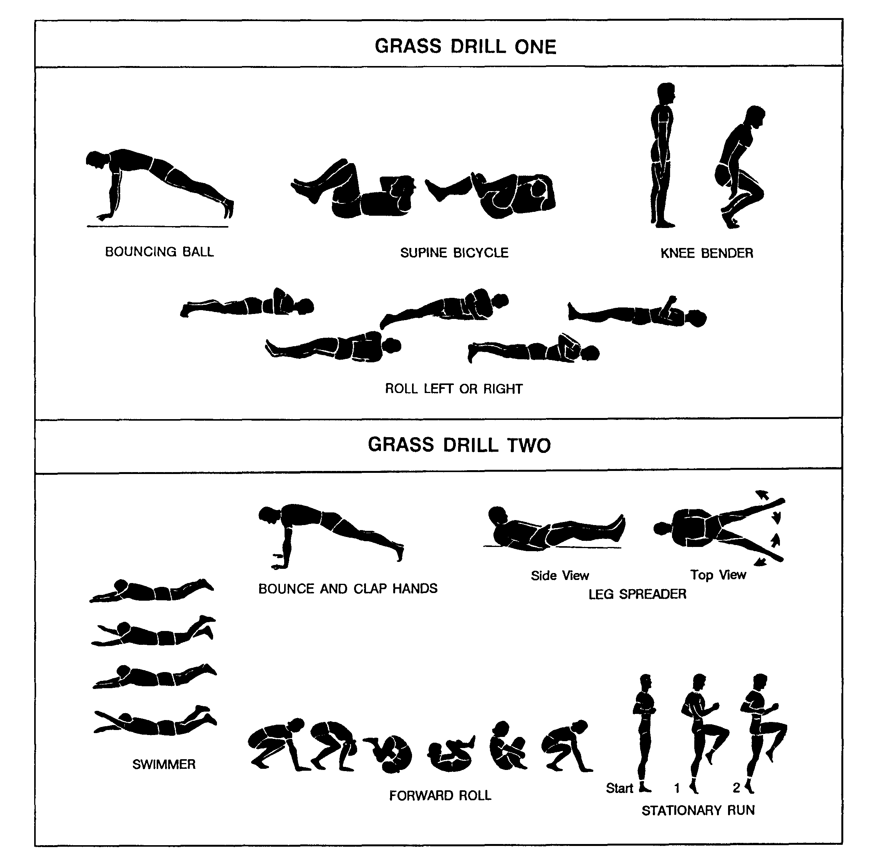
Figure 7-6. Grass Drill Exercises

Sports

Many sports are appropriate for fitness activities in the Cadet Corps class. Basketball, soccer, volleyball, ultimate Frisbee, and other sports offer a good workout and team focus.

UNIT OLYMPICS

The unit Olympics is a multifaceted event that can be tailored to any unit to provide athletic participation for all cadets. The objective is to incorporate into a team-level competition athletic events that represent all five fitness components. The competition can be within a unit or between competing units. When conducted with enthusiasm, it promotes team spirit and provides a good workout. It is a good diversion from the regular PT session.

Types of Events

The Olympics should include events that challenge the cadets’ muscular strength and endurance, aerobic endurance, flexibility, agility, speed, and related sports skills. Events can be held for both individuals and teams, and they should be designed so that both male and female cadets can take part. Each cadet should be required to do a minimum number of events. Teams should wear a distinctively marked item such as a T-shirt or arm band. This adds character to the event and sets teams apart from each other. A warm-up should precede and a cool-down should follow the events. The following are examples of athletic events that could be included in a unit Olympics:

Push-Up Derby

This is a timed event using four-member teams. The objective is for the team to do as many correct push-ups as possible within a four-minute time limit. Only one team member does push-ups at a time. The four team members may rotate as often as desired.

Sandbag Relay

This event uses four-member teams for a running relay around a quarter-mile track carrying sandbags. One player from each team lines up at the starting line carrying a full sandbag. He hands the sandbag off to a teammate when he finishes his part of the race. This continues until the last team player crosses the finish line. Placings are determined by the teams’ order of finish.

Team Flexibility

In this event, if teams are numerically equal, all members of each team should participate. If not, as many team members should participate as possible. Each team’s anchor person places his foot against a wall or a curb. He stretches his other foot as far away as possible as in doing a split. The next team member puts one foot against the anchor man’s extended foot and does a split-stretch. This goes on until all team members are stretched. They cover as much distance as possible keeping in contact with each other. The team that stretches farthest from the start point without a break in their chain is the winner.

Running, Sprints and Relays

Any number of options of distance running, sprints and or relays can be done. The team can split, sending their best runners or sprinters on the harder routes, or the whole team can run/sprint each route. With different lengths, you can get a lot of mileage out of running, sprinting, and relays!

A5. RECOVERY DRILL (RD)

Recovery

Recovery serves to gradually slow the heart rate and helps prevent pooling of the blood in the legs and feet. The purpose of the RD is to develop range of motion and stability to enhance performance, control injuries, and gradually bring the body back to its pre-exercise state. To adequately recover from one PT session to another on consecutive days, cadets must restore hydration and energy through proper fluid intake and nutrition. This recovery period also includes receiving adequate rest and sleep to allow the body to physiologically adapt to the physical stresses of PT.

Training Area

Any dry, level area of adequate size is satisfactory for conduct of the RD.

Formation

The extended rectangular formation is prescribed for the conduct of the RD.

Leadership

Recovery should last about 10 minutes and occur immediately after the activities of the PT session. Cadets should begin recovery after running activities by walking until their heart rates return to less than 100 beats per minute and heavy sweating stops. Each recovery exercise position will be held for about 20 seconds. The sequence of exercises listed in Table 8-3 will be performed in its entirety. The RD will be conducted at the end of all PT sessions, and after the conduct of the obstacle course.

Instruction and Execution

A PT leader and AI are required to lead the RD. The PT leader and AI must be familiar with the method of teaching these exercises, commands, formations, and the use of AIs as described in Lesson W5/A3, Execution of Training. Cadets should memorize the exercises by name and movement. The RD may be conducted by platoon or company in mass. Cadets move in and out of the starting position and exercise positions on the PT leader’s command. Each exercise position is held for about 20 seconds. Cadets begin and terminate each exercise at the starting position, then move to the position of attention. The RD is always performed in the order listed. Considerable time and effort must be expended during the early stages to teach precise performance of each exercise. The PT leader should not execute the RD in cadence and should not count seconds aloud.

Precision

Recovery exercises lose much of their value unless performed exactly as prescribed. PT leaders and AIs must provide verbal feedback and make spot corrections to ensure that the cadets correctly assume the exercise positions.

Integration

Recovery integrates the components of strength and mobility by developing stability and flexibility.

Recovery Drill

Table 8-3 lists the 5, two-position exercises that comprise the RD. These 5 exercises are always performed in the order listed and held for about 20 seconds. The recovery exercises are not given in cadence. Cadets move in and out of the starting position and exercise positions on the PT leader’s command. The seconds are not counted out loud.

Table 8-3. Recovery Drill

1. OVERHEAD ARM PULL | HOLD 20 SECONDS
2. REAR LUNGE | HOLD 20 SECONDS
3. EXTEND AND FLEX | HOLD 20 SECONDS
4. THIGH STRETCH | HOLD 20 SECONDS
5. SINGLE-LEG OVER | HOLD 20 SECONDS

Table 8-4 lists the body segments trained in the conduct of RD.

Table 8-4. Body segments trained in the conduct of the recovery drill

RECOVERY DRILL (RD) | MUSCLES
 | HIPS | THIGHS | LOWER LEGS | CHEST | BACK | TRUNK | SHOULDERS | ARMS
1. OVERHEAD ARM PULL |  |  |  |  | X | X | X | X
2. REAR LUNGE | X | X | X
3. EXTEND AND FLEX | X | X | X | X | X | X | X | X
4. THIGH STRETCH |  | X | X | X |  | X | X | X
5. SINGLE-LEG OVER | X | X |  |  | X | X | X | X

EXERCISE 1: Overhead Arm Pull

Purpose: This exercise develops flexibility of the arms, shoulders, and trunk muscles (Figure 8-12).

Starting Position: Straddle stance with hands on hips.

Position 1: On the command, “Ready, STRETCH,” raise the left arm overhead and place the left hand behind the head. Grasp above the left elbow with the right hand and pull to the right, leaning the body to the right. Hold this position for 20 seconds.

Starting Position: On the command “Starting Position, MOVE,” assume the starting position.

Position 2: On the command “Change Position, Ready, STRETCH,” raise the right arm overhead and place the right hand behind the head. Grasp above the right elbow with the left hand and pull to the left, leaning the body to the left. Hold this position for 20-30 seconds.

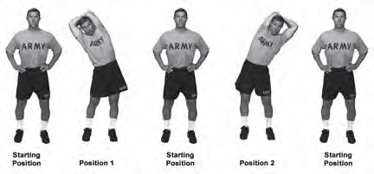
Starting Position: On the command “Starting Position, MOVE,” return to the starting position.

Check Points:
Figure 8-12. Overhead arm pull
- Throughout the exercise, keep the hips set and the abdominals tight.
- In positions 1 and 2, lean the body straight to the side, not to the front or back.

Precaution: N/A
EXERCISE 2: Rear Lunge

Purpose: This exercise develops flexibility of the hip flexors and trunk muscles (Figure 8-13).

Starting Position: Straddle stance, hands on hips.

Position 1: On the command “Ready, STRETCH,” take an exaggerated step backward with the left leg, touching down with the ball of the foot. This is the same position as count 1 of the rear lunge in the PD. Hold this position for 20-30 seconds.

Starting Position: On the command “Starting Position, MOVE,” assume the starting position.

Position 2: On the command “Change Position, Ready, STRETCH,” take an exaggerated step backward with the right leg, touching down with the ball of the foot. This is the same position as count 3 of the rear lunge in the PD. Hold this position for 20-30 seconds.

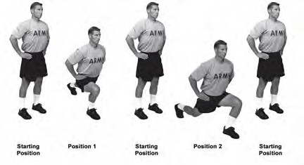
Starting Position: On the command “Starting Position, MOVE,” return to the starting position.

Check Points:
Figure 8-13. Rear lunge
- Maintain straightness of the back by keeping the abdominal muscles tight throughout the motion.
- After the foot touches down on positions 1 and 2, allow the body to continue to lower.
- Lunge and step in a straight line, keeping the feet directed forward. Viewed from the front, the feet are shoulder width apart, both at the starting position and at the end of positions 1and 2.
- Keep the forward knee over the ball of the foot on positions 1 and 2.
- Ensure the heal of the rear foot does not touch the ground.

Precaution: When lunging to the left or right, do not let the knee move forward of the toes.
EXERCISE 3: Extend and Flex

Purpose: This exercise develops flexibility of the hip flexors, abdominals, hip (position 1–extend, Figure 8-14), and the low back, hamstrings, and calves (position 2–flex, Figure 8-14).

Starting Position: The front leaning rest position.

Position 1: On the command “Ready, STRETCH,” lower the body, sagging in the middle, keeping the arms straight and look upward. Hold this position for 20-30 seconds.

Starting Position: On the command “Starting Position, MOVE,” assume the starting position.

Position 2: On the command “Change Position, Ready, STRETCH,” slightly bend the knees and raise the hips upward. Straighten the legs and try to touch the ground with the heels. Move the head in line with the arms, forming an “A” with the body. Keep the feet together and hold this position for 20-30 seconds.

Starting Position: On the command “Starting Position, MOVE,” return to the starting position.
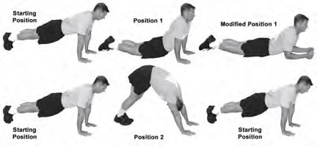

Check Points:
Figure 8-14. Extend and flex
- In position 1, the thighs and pelvis rest on the ground. Relax the back muscles while bearing the bodyweight through the straight arms. Toes point to the rear.
- In position 2, the legs are straight and the arms are shoulder width apart, palms down on the ground.
- Relax the shoulders and push to the rear with the hands, forming an “A” with the body. Try not to round the shoulders.
- Feet are together throughout the exercise.

Precaution: N/A

Variation: Cadets, who are unable to extend the trunk in position 1 while keeping the arms straight and hips on the ground, may assume the modified position 1 shown above.
EXERCISE 4: Thigh Stretch

Purpose: This exercise develops flexibility of the front of the thigh and the hip flexor muscles (Figure 8-15).

Starting Position: Seated position, arms at sides and palms on the floor.

Position 1: On the command “Ready, STRETCH,” roll onto the right side and place the right forearm on the ground, perpendicular to the chest. The right hand makes a fist on the ground with the thumb side up. Grasp the left ankle with the left hand and pull the left heel toward the buttocks and pull the entire leg rearward. Push the left thigh further to the rear with the heel of the right foot. Hold this position for 20-30 seconds.

Starting Position: On the command, “Starting Position, MOVE,” assume the starting position.

Position 2: On the command “Change Position, Ready, STRETCH,” lie on the left side and place the left forearm on the ground, perpendicular to the chest. The left hand makes a fist on the ground with the thumb side up. Grasp the right ankle with the right hand and pull the right heel toward the buttocks pulling the entire leg rearward. Push the right thigh further to the rear with the heel of the left foot. Hold this position for 20-30 seconds.

Starting Position: On the command, “Starting Position, MOVE,” return to the starting position.
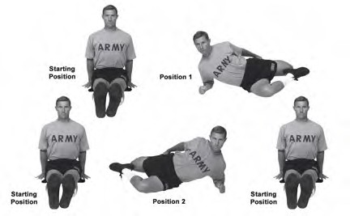

Check Points:

Figure 8-15. Thigh stretch
- Keep the abdominal muscles tight throughout this stretch in order to keep the trunk straight.
- Do not pull the heel forcefully to the buttock if there is discomfort in the knee joint.

Precaution: N/A
EXERCISE 5: Single-Leg Over

Purpose: This exercise develops flexibility of the hips and lower back muscles (Figure 8-16).

Starting Position: Supine position with arms sideward, palms down, and feet together and head on the ground.

Position 1: On the command, “Ready, STRETCH,” turn the body to the right, bend the left knee to 90-degrees over the right leg, and grasp the outside of the left knee with the right hand and pull toward the right. Hold this position for 20-30 seconds.

Starting Position: On the command, “Starting Position, MOVE,” assume the starting position.

Position 2: On the command, “Change Position, Ready, STRETCH,” turn the body to the left, bend the right knee to 90-degrees over the left leg, and grasp the outside of the right knee with the left hand and pull toward the left. Hold this position for 20-30 seconds.

Starting Position: On the command, “Starting Position, MOVE,” return to the starting position.

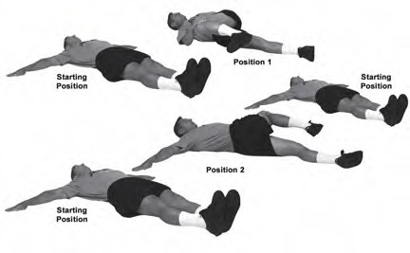

Check Points:
Figure 8-16. Single-leg over
- At the starting position, the arms are directed to the sides at 90-degrees to the trunk; the fingers and thumbs are extended and joined.
- In position 1, keep the left shoulder, arm, and hand on the ground.
- In position 2, keep the right shoulder, arm, and hand on the ground.
- Head remains on the ground throughout the exercise.

Precaution: N/A
Summary

Preparation and recovery are essential elements of every PT session. Conducting PT activities without preparation may adversely affect performance and increase the risk of injury. Recovery enhances mobility and gradually brings the body back to its pre-exercise state. Recovery should also carry over until the next PT session is performed. Restoring adequate hydration and energy through proper nutrition and getting adequate sleep allow the body to refuel, rest, and adapt to the stresses of training.

