CURRICULUM ON MILITARY SUBJECTS

Strand M8: Military Courtesy

Level 11

This Strand is composed of the following components:

1. **Daily Cadet Courtesies**
2. Courtesy to Impress
3. Special Event Courtesies

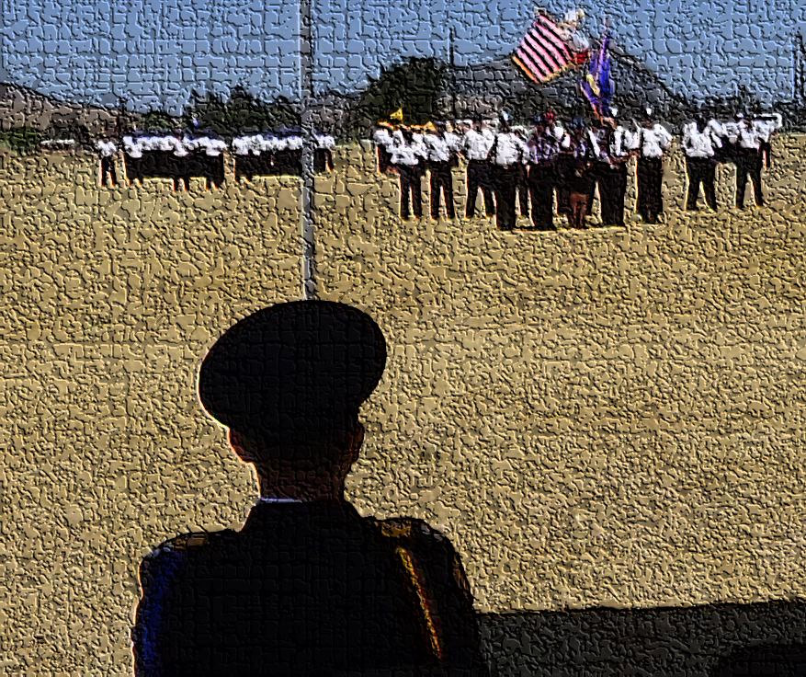

Table of Contents

A. Daily Cadet Courtesies 3

Objectives 3

A1. Introduction to Military Courtesy 4

A2. Rank 5

A3. Addressing People (Title/Sir) 16

A4. Saluting 18

A5. Rules of Saluting: 23

A6. Reporting 26

A7. Position of Attention 27

A8. The Senior’s Position of Honor 28

A9. Cadet Corps Traditions 29

A10. Every Day Courtesies 32

A11. Cadet Corps Taboos 33

A12. Grooming 34

A13. Helping Others 36

A14. Chain of Command 37

A. Everyday Courtesies Vocabulary: 42

References 43

Videos 44

# Daily Cadet Courtesies

## Objectives

**DESIRED OUTCOME (Self-Mastery) / PRACTICUM A**

*90% of Unit Cadets display impeccable military courtesy towards adults and other Cadets during a formal in-ranks inspection. This is equivalent to an Excellent rating on the Annual General Inspection.*

1. Describe what military courtesy is and why it’s important in the Cadet Corps.
2. Identify all Cadet Corps and US Army ranks. Be familiar with the military history of rank. Understand the purpose of each rank.
3. Properly address other cadets, cadet officers, and adult members of all ranks using titles or rank. Know when to use “Sir” and “Ma’am”.
4. Describe the process of saluting. Give the correct verbal greeting for each time of day.
5. Give the correct response to each situation in the Rules for Saluting. Identify what receives a salute (both rank and flag).
6. Report to an officer or NCO correctly in an office or outside.
7. Properly call a room to Attention, or a group or formation outside, upon the approach of an officer.
8. Describe the position of honor for junior and senior personnel walking, posted, or entering a vehicle together.
9. Identify examples of Cadet Corps Customs/Traditions.
10. Identify the basic courtesies cadets should use at all times.
11. Identify from a list Taboos that members of the Cadet Corps will not do.
12. Identify how good grooming shows respect and courtesy for those around you.
13. Describe common courtesies encouraged by the Cadet Corps and ways to help others as part of being a good person.
14. List in order the positions of the chain of command from Cadet through the Governor. Describe the three chains of command that exist within the Cadet Corps structure.

### A1. Introduction to Military Courtesy

Courtesy is essential is all human relationships. It stimulates the harmonious association of individuals, facilitates the conduct of affairs, and adds a welcome element to all manner of human contacts.

Military Courtesy is a required set of rules that govern how members of the military (or Cadet Corps) address and treat each other. While Military Customs are commonly followed voluntarily to carry on traditions of the service, military courtesies (like the salute or respecting someone’s rank) are made mandatory by regulation.

Military courtesy is the display of good manners and politeness in your daily interactions with other Cadets. Courtesy is shown as a sign of respect from both subordinates and seniors to each other. Respect builds loyalty, trust, and teamwork.

The courtesy you learn and practice here in the Cadet Corps will also prepare you for success in any occupation you choose, not just the military.

Courtesy among members of the California Cadet Corps is also vital to maintain discipline. The difference between civilian and military courtesy is that military courtesy was developed in a military atmosphere and has become an integral part of serving in uniform.

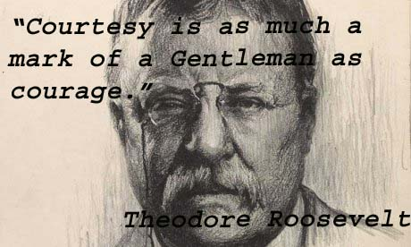Military courtesy is not a one-way street. Enlisted Cadets are expected to be courteous to Cadet officers, and officers are expected to return the courtesy. Mutual respect is a vital part of military courtesy. In the end, military courtesy is the respect shown to each other by members of the same corps.

The California Cadet Corps is comprised of brigades all over the state that instill pride in their cadets because of history, mission, capabilities, and respect that has been earned. A reflection of that pride is visible in the customs, courtesies, and traditions of the California Cadet Corps.



*“When restraint and courtesy are added to strength, the latter becomes irresistible.”*

Mahatma Gandhi



### A2. Rank

In the California Cadet Corps and in the U.S. Military services, rank determines who gets to tell whom what to do. The higher one's rank the more authority and responsibility they have. California Cadet Corps Cadets ranks fall into a few categories: Entry Level Cadets, Sergeants, Senior Sergeants, Warrant Officers, Company Grade Officers, and Field Grade Officers. Each category outranks the group category before it. Working your way up through the different ranks will give you new lessons on leadership as you get a completely different “look” at each level.

#### Brief History of Rank

The California Cadet Corps has adapted its rank from the US Army. The US Army has adapted most of its rank insignia from the British. Before the Revolutionary War, Americans drilled with militia outfits based on the British tradition. Thus, the Continental Army had privates, sergeants, lieutenants, captains, colonels, and generals.

During the Revolutionary War, in 1780, regulations prescribed two stars for major generals and one star for brigadiers worn on shoulder boards, or epaulets. The use of most English ranks carried on even after the United States won the war. The Army and Marine Corps used similar ranks, especially after 1840. Congress gave Second lieutenants their "butter bars" in 1917. Colonels received the eagle in 1832. From 1836, majors and lieutenant colonels were denoted by oak leaf; captains by double silver bars -- "railroad tracks"; and first lieutenants, single silver bars.

Chevrons are V-shaped stripes whose use in the military go back to at least the 12th century. It was a badge of honor and used in heraldry. The British and French used chevrons -- from the French word for "roof" -- to signify the length of service. Chevrons officially denoted rank in the U.S. military for the first time in 1817, when cadets at the U.S. Military Academy at West Point, N.Y., wore them on their sleeves. From West Point, chevrons spread to the Army and Marine Corps. The difference then was chevrons were worn points down until 1902 when Army and Marine Corps enlisted personnel switched to the present ‘points up’ configuration. Chevrons may also be called “bars”.

Warrant officers went through several iterations before the services arrived at today's configuration. The Army and Marines did not have warrants until the 20th century. Rank insignia for warrants last changed with the addition of chief warrant officer 5.

#### Fun Facts about Rank

•"Lieutenant" comes from the French "lieu" meaning "place" (where we get the term “in lieu of”) and "tenant" meaning "holding." Literally, lieutenants are placeholders. The British originally corrupted the French pronunciation, pronouncing the word, "lieuftenant," while Americans (probably because of French settler influence) maintained the original pronunciation.

•While majors outrank lieutenants, lieutenant generals outrank major generals. This comes from British tradition: Generals were appointed for campaigns and often called "captain generals." Their assistants were, naturally, "lieutenant generals." At the same time, the chief administrative officer was the "sergeant major general." Somewhere along the way, "sergeant" was dropped.

•Gold is worth more than silver, but silver outranks gold. This is because the Army decreed in 1832 that infantry colonels would wear gold eagles on an epaulet of silver and all other colonels would wear silver eagles on gold. When majors and lieutenant colonels received the leaves, this tradition could not continue. So, silver leaves represented lieutenant colonels and gold, majors. The case of lieutenants is different: First lieutenants had been wearing silver bars for 80 years before second lieutenants had any bars at all.

•Colonel is pronounced "kernal" because the British adopted the French spelling "colonel" but Spanish pronunciation "coronel" and then corrupted the pronunciation.

•While rank insignia is important, sometimes it isn't smart to wear them. When the rifled musket made its appearance in the Civil War, sharpshooters looked for officers. Officers soon learned to take off their rank insignia as they approached the battle line.

(Powers, 2016)

#### Cadet Corps Ranks

##### Cadets, Sergeant, and Senior Sergeant Ranks

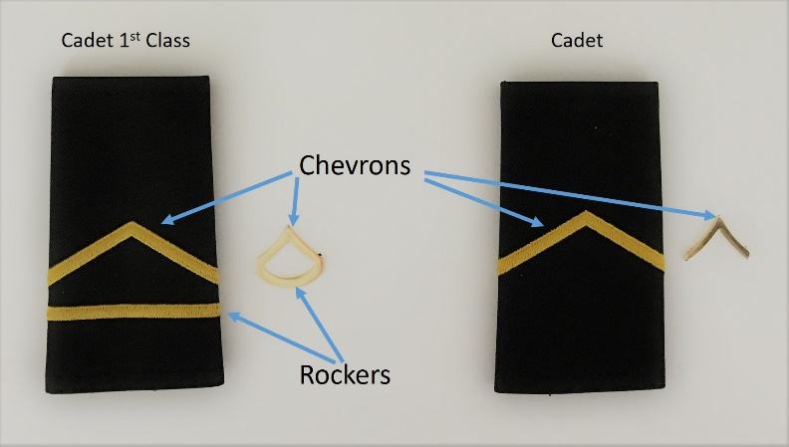In the Cadet Corps, cadets, sergeants, and senior sergeants closely follow “enlisted” soldiers in the US Army. Similarly, chevrons are used to identify classes of ranks. One stripe (chevron) denotes a Cadet, two stripes denote a Corporal, and three stripes denotes Sergeant. Rockers, which are the straight lines on Class-A or Class-B shoulder marks, or u-shaped lines on Class-C, metal, pin on rank are displayed underneath chevrons and indicate various levels of each of the three classes. Thus, a Cadet First Class, has one chevron plus one rocker and a Staff Sergeant, which is the first rank after Sergeant, has 3 chevrons plus one rocker.

#### Cadets (Entry Level)

##### RCT - Cadet Recruit

Recruits wear the uniform without any rank.

*(Addressed as "Cadet")*

Lowest rank: a “Recruit” who’s in their first semester of CACC. Primary role is to carry out orders issued to them to the best of his/her ability.

Squad member.

##### CDT - Cadet

*(Addressed as "Cadet")*

RCTs are advanced to this level after one semester of CACC (or earlier) and passing their PTA. Carries out orders issued to them to the best of his/her ability.

Squad member.

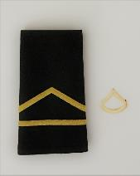

##### CFC - Cadet First Class

*(Addressed as "Cadet")*

CDTs are advanced to this level after their second semester of CACC (or earlier) and passing their PTA. Carries out orders issued to them to the best of his/her ability.

Squad member.

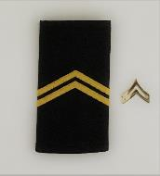

##### C/CPL - Cadet Corporal

*(Addressed as "Corporal")*

CFCs are advanced to this level after their third semester of CACC (or earlier) and passing their PTA. Carries out orders issued to them to the best of his/her ability.

Squad member.

#### Sergeants

##### C/SGT - Cadet Sergeant

*(Addressed as "Sergeant")*

CPLs are promoted to this level after taking the C/SGT exam and passing their PTA. This is the first official leadership position. Considered to have the greatest impact on Cadets because SGTs oversee them in their daily tasks. SGTs set an example and the standard for Entry-Level Cadets to look up to, and live up to.

Assistant Squad Leader (5-11 Cadets).

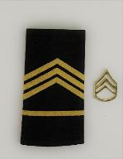

##### C/SSG - Cadet Staff Sergeant

*(Addressed as "Sergeant")*

SGTs are promoted to this level after taking the C/SSG exam and passing their PTA. Also, commands a squad (9 to 10 Cadets). Often has one or more SGTs under their leadership.

Squad Leader (5-11 cadets), Company Clerk/Guidon Bearer, Battalion Staff NCO.

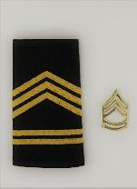

##### C/SFC - Cadet Sergeant First Class

*(Addressed as "Sergeant")*

SSGs are promoted to this level after passing a promotion board and completing their PTA. SFCs are key to staff function and advising the platoon leader.

Platoon Sergeant, Company Supply Sergeant, Battalion Staff NCO, Regimental Staff NCO

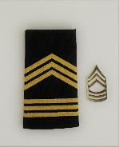

##### C/MSG - Cadet Master Sergeant

*(Addressed as "Sergeant")*

SFCs are promoted to this level after passing a promotion board and completing their PTA. Principal NCO at the Battalion, and all staff levels.

Battalion/Regimental/Brigade/10th Corps Staff NCO

#### Senior Sergeants

##### C/1SG - Cadet First Sergeant

*(Addressed as "First Sergeant")*

SFCs or MSGs are promoted to this level after passing a promotion board and completing the MSG PTA and being assigned to the First Sergeant Position. Principal NCO and life-blood of the company: the trainer, tutor, and wise counselor. Instructs other SGTs, advises the Commander and helps train Cadets.

Company First Sergeant, HHC First Sergeant

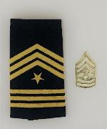

##### C/SGM - Cadet Sergeant Major

*(Addressed as " Sergeant Major ")*

1SGs or MSGs are promoted to this level after passing a promotion board. SGMs experience and abilities are equal to that of the CSM, but the sphere of influence regarding leadership is generally limited to those directly under his charge.

Battalion Operations NCO, Regimental/Brigade/10th Corps Staff NCO

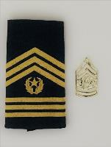

##### C/CSM - Cadet Command Sergeant Major

*(Addressed as "Command Sergeant Major")*

SGMs are promoted to this level after passing a promotion board. CSMs normally serve at the Brigade level and above.

Battalion/Regiment/Brigade/10th Corps Command Sergeant Major

#### Company Grade, and Field Grade Officers

In the Cadet Corps, company grade officers and field grade officers exactly follow the US army ranks of Second Lieutenant through Colonel. The symbols of these officers (bars, oak leaves, and eagle) however have been replaced with circles and diamonds. Gold and silver-colored circles represent the company grade officers of Second Lieutenant, First Lieutenant, and Captain. Gold and silver-colored diamonds represent the field grade officers. As in the US Army, silver out-ranks gold.

##### Company Grade Officers



##### C/2LT - Cadet Second Lieutenant

*(Addressed as "Lieutenant")*

SSGs and above are promoted to this entry-level officer rank after completing OCS, Promotion Board, and Officer PTAs . Leads platoon-size elements consisting of the platoon SGT and two or more squads (Commands at least 14 Cadets).

Platoon Leader, Company Staff Officer



##### C/1LT - Cadet First Lieutenant

*(Addressed as "Lieutenant")*

2LTs are promoted to the senior lieutenant rank after completing a promotion board and 1LT PTAs. 1LTs are often assigned as the Company XO.

Company Executive Officer, Battalion Staff Officer

##### C/CPT - Cadet Captain

*(Addressed as "Captain")*

1LTs are promoted to this rank after completing a promotion board and Captain PTAs. Captains command Companies (at least 32 cadets) and are primary staff officers at the Battalion

Company Commander, Battalion Staff Officer

##### Field Grade Officers

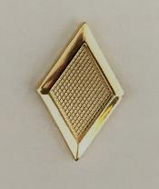

##### C/MAJ - Cadet Major

*(Addressed as "Major")*

CPTs are promoted to this rank after completing a promotion board and Major PTAs. Majors are primarily staff officers.

Battalion Executive Officer, Regimental/Brigade/10th Corps Staff Officer

##### 

##### C/LTC - Cadet Lieutenant Colonel

*(Addressed as "Colonel")*

MAJs are promoted to this rank after completing a promotion board and LTC PTAs. Lieutenant Colonels command battalions and regiments.

Battalion/Regimental Commander, Brigade Deputy/XO, 10th Corps Staff Officer

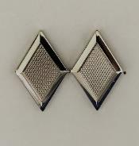

##### C/COL - Cadet Colonel

*(Addressed as "Colonel")*

LTCs are promoted to this rank after completing a promotion board and COL PTAs. Colonels command brigades and the 10th Corps (Several thousand cadets)

Brigade Commander, !0th Corps Command Element

#### US Army Enlisted Soldiers

##### **PRIVATEPRIVATE (PVT/PV2)**

(Addressed as "Private")   
Lowest rank: a trainee who’s starting Basic Combat Training (BCT). Primary role is to carry out orders issued to them to the best of his/her ability. (PVT does not have an insignia)

##### PRIVATE FIRST CLASSPRIVATE FIRST CLASS (PFC)

(Addressed as "Private")   
PV2s are promoted to this level after one year—or earlier by request of supervisor. Individual can begin BCT at this level with experience or prior military training. Carries out orders issued to them to the best of his/her ability.

##### SPECIALISTSPECIALIST (SPC)

(Addressed as "Specialist")   
Can manage other enlisted Soldiers of lower rank. Has served a minimum of two years and attended a specific training class to earn this promotion. People enlisting with a four-year college degree can enter BCT as a Specialist.

##### CORPORALCORPORAL (CPL)

(Addressed as "Corporal")   
The base of the Non-Commissioned Officer (NCO) ranks, CPLs serve as team leader of the smallest Army units. Like SGTs, they are responsible for individual training, personal appearance and cleanliness of Soldiers.

##### SERGEANTSERGEANT (SGT)

(Addressed as "Sergeant")   
Typically commands a squad (9 to 10 Soldiers). Considered to have the greatest impact on Soldiers because SGTs oversee them in their daily tasks. In short, SGTs set an example and the standard for Privates to look up to, and live up to.

##### STAFF SERGEANT STAFF SERGEANT (SSG)

(Addressed as "Sergeant")   
Also commands a squad (9 to 10 Soldiers). Often has one or more SGTs under their leadership. Responsible for developing, maintaining and utilizing the full range of his Soldiers' potential.

##### SERGEANT FIRST CLASSSERGEANT FIRST CLASS (SFC)

(Addressed as "Sergeant")   
Key assistant and advisor to the platoon leader. Generally, has 15 to 18 years of Army experience and puts it to use by making quick, accurate decisions in the best interests of the Soldiers and the country.

##### MASTER SERGEANTMASTER SERGEANT (MSG)

(Addressed as "Sergeant")   
Principal NCO at the battalion level, and often higher. Not charged with all the leadership responsibilities of a 1SG, but expected to dispatch leadership and other duties with the same professionalism.

##### FIRST SERGEANTSERGEANT MAJORCOMMAND SERGEANT MAJORSERGEANT MAJOR OF THE ARMYFIRST SERGEANTFIRST SERGEANT (1SG)

(Addressed as "First Sergeant")   
Principal NCO and life-blood of the company: the provider, disciplinarian and wise counselor. Instructs other SGTs, advises the Commander and helps train all enlisted Soldiers. Assists Officers at the company level (62 to 190 Soldiers).

##### SERGEANT MAJORSERGEANT MAJOR (SGM)

(Addressed as "Sergeant Major")   
SGMs experience and abilities are equal to that of the CSM, but the sphere of influence regarding leadership is generally limited to those directly under his charge. Assists Officers at the battalion level (300 to 1,000 Soldiers).

##### COMMAND SERGEANT MAJORCOMMAND SERGEANT MAJOR (CSM)

(Addressed as " Command Sergeant Major")  
Functioning without supervision, a CSM’s counsel is expected to be calm, settled and accurate—with unflagging enthusiasm. Supplies recommendations to the commander and staff, and carries out policies and standards on the performance, training, appearance and conduct of enlisted personnel. Assists Officers at the brigade level (3,000 to 5,000 Soldiers).

##### SERGEANT MAJOR OF THE ARMYSERGEANT MAJOR OF THE ARMY

There’s only one Sergeant Major of the Army. This rank is the epitome of what it means to be a Sergeant and oversees all Non-Commissioned Officers. Serves as the senior enlisted advisor and consultant to the Chief of Staff of the Army (a four-star General).

#### US Army Warrant Officers

The Army Warrant Officer is an adaptive technical expert, combat leader, trainer, and advisor. Through progressive levels of expertise in assignments, training, and education, the Warrant Officer administers, manages, maintains, operates, and integrates Army systems and equipment across the full spectrum of Army operations. Warrant Officers are formally addressed as either Mr. or Ms.

WARRANT OFFICER 1

##### WARRANT OFFICER 1 (WO1)

Appointed by warrant from the Secretary of the Army. WO1s are technically and tactically focused officers who perform the primary duties of technical leader, trainer, operator, manager, maintainer, sustainer, and advisor.

##### CHIEF WARRANT OFFICER 2CHIEF WARRANT OFFICER 2 (CW2)

Chief Warrant Officers become commissioned officers as provided by the President of the United States.   CW2s are intermediate level technical and tactical experts who perform increased duties and responsibilities at the detachment through battalion levels.

##### CHIEF WARRANT OFFICER 3CHIEF WARRANT OFFICER 3 (CW3)

Advanced-level experts who perform the primary duties that of a technical and tactical leader. They provide direction, guidance, resources, assistance, and supervision necessary for subordinates to perform their duties. CW3s primarily support operations levels from team or detachment through brigade.

##### CHIEF WARRANT OFFICER 4CHIEF WARRANT OFFICER 4 (CW4)

Senior-level experts in their chosen field. They primarily support battalion, brigade, division, corps, and echelons above corps operations. CW4s typically have special mentorship responsibilities for other WOs and provide essential advice to commanders on WO issues.

##### CHIEF WARRANT OFFICER 5CHIEF WARRANT OFFICER 5 (CW5)

Master-level technical and tactical experts that support brigade, division, corps, echelons above corps, and major command operations. They provide leader development, mentorship, advice, and counsel to WOs and branch officers. CW5s have special WO leadership and representation responsibilities within their respective commands.

#### US Army Officers

SECOND LIEUTENANT

##### SECOND LIEUTENANT (2LT)

(Addressed as "Lieutenant")   
Typically the entry-level rank for most Commissioned Officers. Leads platoon-size elements consisting of the platoon SGT and two or more squads (16 to 44 Soldiers).

##### FIRST LIEUTENANTFIRST LIEUTENANT (1LT)

(Addressed as "Lieutenant")  
A seasoned lieutenant with 18 to 24 months’ service. Leads more specialized weapons platoons and indirect fire computation centers. As a senior Lieutenant, they are often selected to be the Executive Officer of a company-sized unit (110 to 140 personnel).

##### CAPTAINCAPTAIN (CPT)

(Addressed as "Captain")  
Commands and controls company-sized units (62 to 190 Soldiers), together with a principal NCO assistant. Instructs skills at service schools and The United States Army combat training centers and is often a Staff Officer at the battalion level.

##### MAJORMAJOR (MAJ)

(Addressed as "Major")  
Serves as primary Staff Officer for brigade and task force command regarding personnel, logistical and operational missions.

##### LIEUTENANT COLONELLIEUTENANT COLONEL (LTC)

(Addressed as "Lieutenant Colonel " or "Colonel")   
Typically commands battalion-sized units (300 to 1,000 Soldiers), with a CSM as principal NCO assistant. May also be selected for brigade and task force Executive Officer.

##### COLONELCOLONEL (COL)

(Addressed as "Colonel")   
Typically commands brigade-sized units (3,000 to 5,000 Soldiers), with a CSM as principal NCO assistant. Also, found as the chief of divisional-level staff agencies.

#### US Army Generals

BRIGADIER GENERAL

##### BRIGADIER GENERAL (BG)

(Addressed as "General")   
Serves as Deputy Commander to the commanding general for Army divisions. Assists in overseeing the staff's planning and coordination of a mission.

MAJOR GENERAL

##### MAJOR GENERAL (MG)

(Addressed as "General")   
Typically commands division-sized units (10,000 to 15,000 Soldiers).

LIEUTENANT GENERAL

##### LIEUTENANT GENERAL (LTG)

(Addressed as "General")   
Typically commands corps-sized units (20,000 to 45,000 Soldiers).

##### GENERALGENERAL (GEN)

(Addressed as "General")   
The senior level of Commissioned Officer typically has over 30 years of experience and service. Commands all operations that fall within their geographical area. The Chief of Staff of the Army is a four-star General.

##### GENERAL OF THE ARMYGENERAL OF THE ARMY (GOA)

This is only used in time of War where the Commanding Officer must be equal or of higher rank than those commanding armies from other nations. The last officers to hold this rank served during and immediately following WWII.

### A3. Addressing People (Title/Sir)

Effrontery: [əˈfrən(t)ərē] (noun) rude or arrogant behavior



“If we accept being talked to any kind of a way, then we are telling ourselves we are not quite worth the best. And if we have the effrontery to talk to anybody with less than courtesy, we tell ourselves and the world we are not very intelligent.”

Maya Angelou



#### TITLES

One military courtesy is the use of titles to show respect. When you are talking to someone in the Cadet Corps or the military, address that person by his or her rank. This form of a courtesy is not only a standard greeting, but it shows respect for the responsibility that person has earned.

Displayed below are the correct titles by which you should address most individuals in the Cadet Corps or the US Army:

All Generals: “General”

Colonels and Lieutenant Colonels: “Colonel”

Majors: “Major”

Captains: “Captain”

Lieutenants: “Lieutenant”

Officer Candidate: “Candidate”

Warrant Officers: “Mister” or “Miss”

Sergeants Major: “Sergeant Major”

First Sergeants: “First Sergeant”

All other Sergeants: “Sergeant”

Corporals: “Corporal”

All Specialists: “Specialist”

Recruits, Cadets and Cadets First Class: “Cadet”

Privates and Privates First Class: “Private”

#### SIR/MA’AM

If you do not know the person’s name, you may address them by their rank, or male officers as “Sir” and female officers as “Ma’am”. Conversation with others in the Cadet Corps should be formal and correct. Use proper titles to show respect and indicate rank. Senior CACC cadets may address junior CACC cadets by their first name, but not the other way around.

Warning: If you're talking to an NCO, do not address them as sir or ma'am.

#### Addressing military members

Commissioned officers (and to a lesser extent, warrant officers) run the U.S. Military. They are the top dogs. As such, they're always addressed politely, using sir or ma'am.

*Tip: In the Cadet Corps, Commandants are also addressed as sir or ma'am. Don't overuse these terms, though. In other words, don't say something like, "Sir, I have to go to the bathroom, sir." Otherwise, you're likely to hear a (very loud) speech about a sir sandwich.*

#### Responses to Questions

When answering an Officer’s yes or no question, all responses will be answered with a “Yes Sir” or “Yes Ma’am” for affirmative answers or “No Sir” or “No Ma’am” for negative answers. When an NCO asks a yes or no question, all responses will be answered with a “Yes Sergeant/First Sergeant/Sergeant Major” for affirmative answers or “No Sergeant/First Sergeant/Sergeant Major” for negative answers. And finally, when the cadet in charge is a Recruit, Cadet, or Cadet First Class, the correct response is “Yes Cadet” or “No Cadet”. Remember, do not call NCOs or Cadets “sir” or “ma’am”.

Answering a “why?” question can be tricky when one considers the military custom of not offering excuses. For example, if your female Commandant asks you why you forgot your cover today, an appropriate initial response may be “No excuse Ma’am!” If the Officer really wants to know why, she may follow up with another question asking for an explanation.

*Tip: In the Cadet Corps, excuses are not offered and when asked why you didn’t do something respond with “No excuse Sir/Ma’am”*

### A4. Saluting



Always give a word or sign of salute when meeting or passing a friend, or even a stranger, if in a lonely place.

Tecumseh



#### Military Salute History

[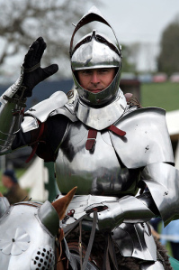](https://fasab.files.wordpress.com/2013/04/armored-knight.jpg)The salute is a gesture of respect and trust among cadets. Remember, the salute is not only prescribed by regulation, but is also recognition of each other's commitment, abilities, and professionalism.

Some historians believe the hand salute began in late Roman times when assassinations were common. A citizen who wanted to see a public official had to approach with his right hand raised to show that he did not hold a weapon. Knights in armor raised visors with the right hand when meeting a comrade. This practice gradually became a way of showing respect and, in early American history, sometimes involved removing the hat. By 1820, the motion was modified to touching the hat, and since then it has become the hand salute used today. You salute to show respect toward an officer, flag, or our country.

The salute is widely misunderstood outside the military. Some consider it to be a gesture of servility since the junior extends a salute to the senior, but we know that it is quite the opposite. The salute is an expression that recognizes each other as a member of the profession of arms; that they have made a personal commitment of self-sacrifice to preserve our way of life. The fact that the junior extends the greeting first is merely a point of etiquette-a salute extended or returned makes the same statement.

*Tip: Practice saluting in front of a mirror. The way you salute says a lot about you as a Cadet. A smart salute shows pride in yourself and your unit. A sloppy salute might mean that you're ashamed of your unit, lack confidence, or at the very least, that you haven't learned how to salute correctly.*

#### How to Salute

The junior person shall salute first. Accompanying the rendering of the hand salute with an appropriate greeting such as, "Good Morning, Sir" or "Good Morning, Ma’am" is expected.

In saluting, turn your head and eyes toward the person or flag you are saluting. Bring your hand up to the correct position in one, smart motion without any preparatory movement. When dropping the salute, bring your hand directly down to its natural position at your side, without slapping your leg or moving your hand out to the side. Any flourish in the salute is improper.

[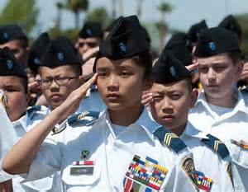](https://www.bing.com/images/search?q=california+cadet+corps+salute&view=detailv2&&id=ED9EC088C6BB04AFA84F67A41D2483744A0B5C2B&selectedIndex=4&ccid=Ar9uIr8V&simid=608020512512213785&thid=OIP.M02bf6e22bf15f79c7270f8d463de911bo0)

The proper way to salute when wearing the beret, garrison cap, or without headgear is to raise your flat right hand until the tip of your forefinger touches the outer edge of your right eyebrow (just above and to the right of your right eye).

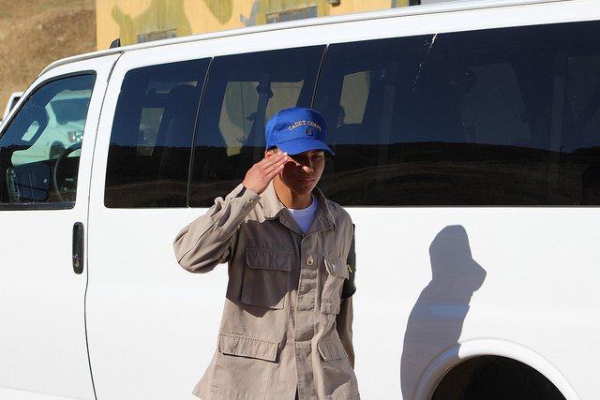

When wearing headgear with a visor, the forefinger touches the right front corner of the visor. Your fingers are together, straight, and your thumb snug along the hand in line with the fingers, and not across your palm. Your hand, wrist, and forearm are straight, forming a straight line from your elbow to your fingertips. Your upper arm (elbow to shoulder) is horizontal to the ground.

* All junior CACC personnel will salute an officer senior to them.
* Salutes should be rendered approximately 6-paces away.
* When passing an officer from behind, you salute and say “By your leave, sir/ma’am”.

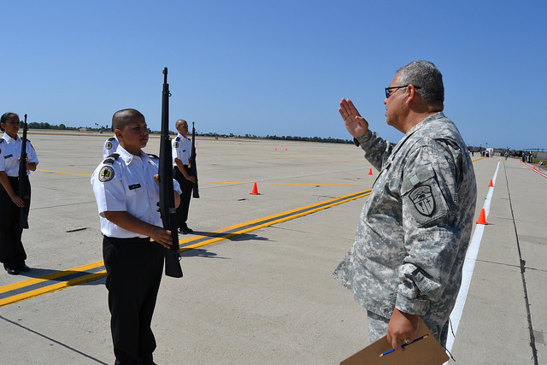

Salutes are also rendered to officers or the flag when carrying rifles, sabers and guidons (under arms) by bringing the rifle, saber, or guidon to Present Arms position. Details on these positions are further described in the Drill and Ceremonies Strand.

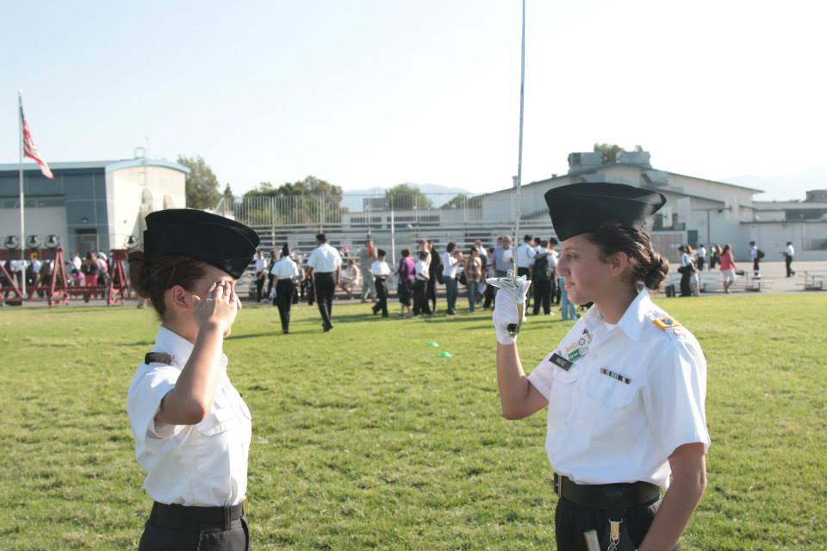

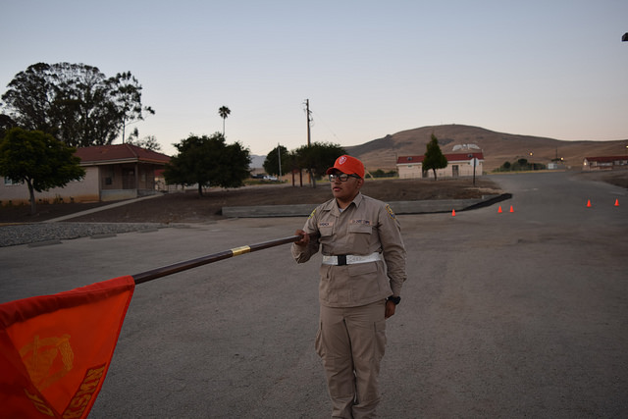

*Tip: Rendering a salute is not required when arms are encumbered. However, one should always extend a verbal greeting or respond to one. (Note: You should always salute a senior officer if he/she is encumbered and you are not, even though the salute cannot be returned.)*

*Practical Exercise*

*Have all the cadets in the class or group line up in two lines facing each other. Have them salute and give feedback to each other on the important points, including sharpness. Is the upper arm parallel to the ground? Is the hand flat with the thumb along the side of the index finger and not sticking up or down? Is the finger touching the side of the eyebrow or glasses? Did the cadet raise his/her salute in one sharp movement straight up and down? The instructor or cadet leaders should go through the line and see how the cadets are doing, pointing out ways to improve.*

#### Saluting in Groups (Not formation)

If in the company of a senior officer and a junior officer approaches, salute at the same time as the senior. If you outrank the approaching officer, hold your salute until the senior officer drops his or her salute. If the approaching officer is of higher rank than you are, drop your salute after the approaching officer drops his or her salute.

When in the company of a senior officer and a more senior officer approaches, tactfully ensure the first officer is aware of the senior’s approach. When the first officer salutes, salute at the same time. If in the company of a senior officer who is unaware of a junior’s salute, do not interrupt by rendering a salute to the junior.

When a senior officer approaches, the first individual noticing the officer calls the group to attention (Group, ATTENTION). All members face the officer and salute. If the officer addresses an individual or the group, all remain at attention (unless otherwise ordered) until the end of the conversation, at which time they salute the officer.

#### California Cadet Corps Standard Greeting

|  |  |
| --- | --- |
| **Time of Day** | **Greeting** |
| 0000-1159:59 | “Good Morning Sir/Ma’am/Sergeant” |
| 1200-1659:59 | “Good Afternoon Sir/Ma’am/Sergeant” |
| 1700-2359:59 | “Good Evening Sir/Ma’am/Sergeant” |

When in uniform at public gatherings, such as sporting events, meetings, or when a salute would be inappropriate or impractical, salutes between individuals need not be rendered. If you can’t salute, you should still attempt to render a respectful verbal greeting.

*Any cadet, NCO, or officer recognizing a need to salute or a need to return one may do so anywhere at any time. When in doubt, salute!*

A good rule of thumb is this: if you are outdoors and it is practical to salute, do so. Outdoors includes theater marquees, shelters over gas station pumps, covered walkways, and other similar shelters that are open on the sides.

#### Practical Exercise

*Form in groups of 5, or by squad. Assign roles – one cadet plays a C/1LT, one cadet a C/MAJ, one a C/CSM, and two are Cadets. Have the C/MAJ approach the group, and in slow motion, go through the saluting/greeting process. The first person to see the C/MAJ commands “Group, Attention”, and all cadets salute. The C/MAJ returns the salute. The cadets remain at Attention unless the C/MAJ puts them at ease. When the C/MAJ leaves, the cadets all come to Attention, and all salute. The C/MAJ returns the salute, and walks away.*

*Now switch roles. Have the C/1LT approach the group. The Cadets and C/CSM salute the C/1LT, who salutes the C/MAJ. The C/MAJ returns the salute. The C/1LT drops his/her salute, then the Cadets and C/CSM drop their salutes.*

*Repeat this in various forms, with different ranks approaching the group.*

### A5. Rules of Saluting:

|  |  |  |
| --- | --- | --- |
| **Dress** | **Situation** | **Correct Response** |
| **OUTDOORS** | | |
| Uniform | **US flag is raised or lowered**  *Note: Accompanied by *Reveille* or *Retreat* or *National Anthem* being played | Stop, stand at attention, face the flag and salute until flag is finished being raised or lowered or last note of music is played. |
| Uniform | **US Flag passes by** | Stop, stand at attention and salute until flag is 6 paces away |
| Uniform | **Pass by an officer** | Salute and greet him/her 6 paces away, continue walking without stopping |
| Uniform | **Pass an officer from behind** | Salute and greet with “By your leave, Sir/Ma’am” and continue walking without stopping |
| Uniform | **Reporting to an officer** | Salute and say “Sir/Ma’am, Cadet (include your rank and name) reporting as ordered.” |
| Uniform | **Reporting to an NCO** | Stand at Parade Rest and say “Sergeant (or First Sergeant or Sergeant Major), Cadet (include your rank and name) reporting as ordered.” |
| Uniform | **Reciting the *Pledge of Allegiance*** | Salute and recite the pledge |
| Civilian | **US flag is raised or lowered**  *Note: Accompanied by *Reveille* or *Retreat* or *National Anthem* being played | Stop, stand at attention, put your hand over your heart, and face the flag until it is finished being raised or lowered or last note of music is played. |
| Civilian | **US Flag passes by** | Stop, stand at attention until flag is 6 paces away |
| Civilian | **Pass by an officer** | Greet him/her 6 paces away, continue walking |
| Civilian | **Pass an officer from behind** | Greet with “By your leave, Sir/Ma’am” and continue walking without stopping |
| Civilian | **Reporting to an officer** | Stand at attention and say “Sir/Ma’am, Cadet (include your rank and name) reporting as ordered.” |
| Civilian | **Reporting to an NCO** | Stand at parade rest and say “Sergeant (or First Sergeant or Sergeant Major), Cadet (include your rank and name) reporting as ordered.” |
| **IN FORMATION (IN-PLACE OR MARCHING)** | | |
| Civilian | **Reciting the *Pledge of Allegiance*** | Place your hand over your heart and recite the pledge |
| Uniform | **US flag is raised or lowered** | Entire Formation Salutes at “Present, Arms” Command |
| Uniform | **An officer passes by** | Formation’s leader salutes on behalf of the unit, continues marching without stopping. If at Parade Rest or At Ease, the formation is called to Attention. |
| Civilian | **US flag is raised or lowered** | Entire formation stands at attention and salutes |
| Civilian | **An officer passes by** | Formation’s leader greets officer on behalf of the unit, continues marching without stopping. If at Parade Rest or At Ease, the formation is called to Attention |
| **IN DOORS** | | |
| Uniform or Civilian | **Reciting the *Pledge of Allegiance*** | Stand at attention, place your hand over your heart and recite the Pledge |
| Uniform or Civilian | **Reporting to an officer** | Salute and say “Sir/Ma’am, Cadet (include your rank and name) reporting as ordered.” |
| Uniform or Civilian | **Reporting for a Board** | Salute the Board President and say “Sir/Ma’am/Sergeant Cadet (include your rank and name) reporting for board.” |
| Uniform or Civilian | **Reporting to an NCO** | Stand at parade rest and say “Sergeant (or First Sergeant or Sergeant Major), Cadet (include your rank and name) reporting as ordered.” |
| Uniform or Civilian | **Pass by an officer or passing from behind** | Greet officer |
| Uniform or Civilian | **US Flag passes by; National anthem is Sung** | Stand at attention and place your hand over your heart (If in civilian clothes) |

#### What to Salute

Flag of the United States:

-As it’s being raised or lowered

-As it’s passing by in a parade

-As you are passing by it in a parade

-As you are pledging allegiance outdoors (CACC-only)

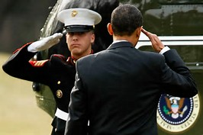

Commander in Chief:

-President of the United States

-Governor of the State of California

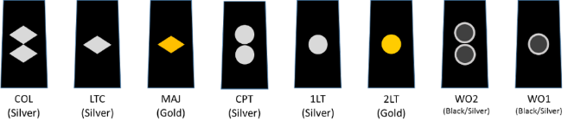

Officers in the CACC:

-Warrant Officers

-Company Grade Officers (2LT-CPT)

-Field Grade Officers (MAJ-COL)

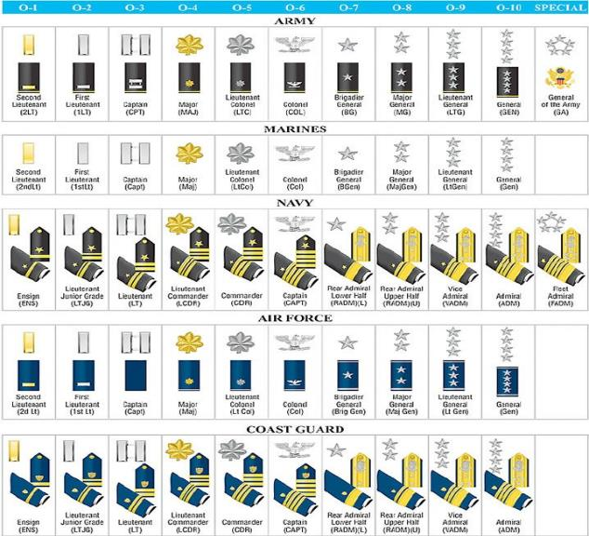

Officers in the military:

-Army

-Navy

-Air Force

-Marines

-Coast Guard

-California State Military Forces

-Officers of Foreign countries

(If you recognize them)

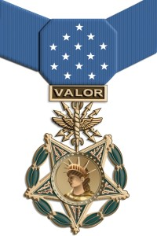

Congressional Medal of Honor winners (of any rank)

#### Practical Exercise

*Before the class or training session, make up flashcards with the different rank insignia on them. Include cadet and Army ranks. Shuffle the deck, and hold up a card with a rank insignia. Have your cadets tell you whether they should salute that rank or not. This can be done in class, or by Squad Leaders or other unit leaders.*

### A6. Reporting

https://tse1.mm.bing.net/th?&id=OIP.Me3014851eba295abc4f9a7d8f236b6fao0&w=56&h=139&c=0&pid=1.9&rs=0&p=0&r=0

#### Reporting Indoors

When reporting to an officer in his office, the Cadet removes his headgear, knocks twice, and enters when told to do so. He approaches within two steps of the officer's desk, *halts*, *salutes,* and reports, ***"Sir (Ma'am), Recruit Jones reporting as ordered."*** The *salute* is held until the report-in is completed and *the salute* has been returned by the officer. When the business is completed, the cadet *salutes,* holds the *salute* until it has been returned, executes an about face*,* and departs. When reporting indoors under arms, the procedure is the same except that the headgear is not removed and the cadet renders the *salute* prescribed for the weapon with which he is armed.

*Tip: Cadets told to report to an officer should double time to the officer’s location.*

*Tip: When reporting to a Non-Commissioned Officer the salute is not rendered and the “Sir/Ma’am” is replaced with rank*

#### Reporting Outdoors

When reporting outdoors, the Cadet moves rapidly toward the officer, *halts* approximately three steps from the officer, *salutes,* and reports (as when indoors). When the Cadet is *dismissed* by the officer, *salutes* are again exchanged. If under arms, the Cadet carries the weapon in the manner prescribed for *saluting*.

#### Practical Exercise

*Split into groups by squad, and spread out into different offices or rooms, or corners of a room. Have each cadet go through the reporting sequence, with the Squad Leader in a simulated office – knock, enter, report, stand or sit at ease, dismissal, departure. The whole squad should watch and critique what goes right and wrong. Then do it again until it’s correct!*

### A7. Position of Attention

#### When talking with a superior, stand at:

***Attention.*** The position of attention is assumed when any enlisted Cadet is talking to an officer, or when any Officer is talking to a senior officer. The attention position should be maintained until relieved with an “at ease”, “as you were”, “at rest” or similar statement.

***At Ease***. Enlisted Cadets assume this position when addressing all noncommissioned officers or when noncommissioned officers address noncommissioned officers of superior rank.

#### When some superior walks in, call the room to:

***“Room, Attention”***-If an officer walks into the room and you are the first person to see him or her. If there is already an officer in the room, only call it to attention if the new officer out-ranks the officer already in the room. Remain at attention until relieved with an “at ease”, “as you were”, “at rest”, “carry on” or similar statement.

***“Room, At Ease”***- When an NCO of superior rank enters the room, the first cadet to recognize the NCO calls the room to "At ease." Remain at ease until relieved.

***Nothing-*** When an officer, higher in rank than those present, enters a classroom, recreation area, or dining facility where people are working, eating, or playing, the group is not required to stand at attention. The officer should be greeted by the person in charge. During Mess, the command “At Ease” may be given, however you should remain seated, stay silent, and continue eating. Leaders, under normal circumstances, do not want to interrupt limited meal time.

#### Practical Exercise

*Choose 5 role players, and give them a card that shows a rank insignia for a cadet or adult officer. Post one in the room, and the rest outside the room. Agree on a scenario for what’s happening in the room – i.e. class in session, group of cadets hanging out, cadets studying, etc. Have the role players enter the room one at a time, and enact the proper response in the room for that situation.*

*For example, if cadets are hanging out, with the senior person in the room being a C/1LT, if a C/CPT walks in, the first person to see the C/CPT calls the room to Attention. If the C/CPT is in the room and a C/1LT walks in, the room is not called to Attention (because the senior person is already in the room).*

### A8. The Senior’s Position of Honor

A long-held military tradition dictates that you should always walk on the left side of senior ranking individuals. For hundreds of years men fought with swords and shields. Most warriors carried the sword in their right and the shield in their left hand. Individuals and units who were proud of their fighting ability and desire to go offensive requested the right side of the battle line as a post of honor. Thus, the right became the honored side. When you permit a senior ranking individual to sit or walk on your right, you’re showing them respect by allowing them to symbolically fill the post of honor.

*Tip: When walking, or riding with an officer of higher rank, the lower ranking individual walks or rides on the left. The highest-ranking person, therefore, is on the right.*

One exception to this rule is during In-Ranks inspections, when the senior inspector is to the left and as a result has the best vantage point from which to conduct the inspection. The unit’s leader (Company Commander, Platoon Leader) is *leading* the inspector through his/her unit.

#### Transportation Etiquette

When entering a car, the junior ranking person enters first, with the senior person entering last. When leaving the car, the senior officer goes first. For example, if a lieutenant, colonel and a general were going to ride in the back seat of a car, the lieutenant would enter first, followed by the colonel and then the general (the car driver would open and close the door). When leaving, the general would go first, followed by the colonel and then the lieutenant.

### A9. Cadet Corps Traditions

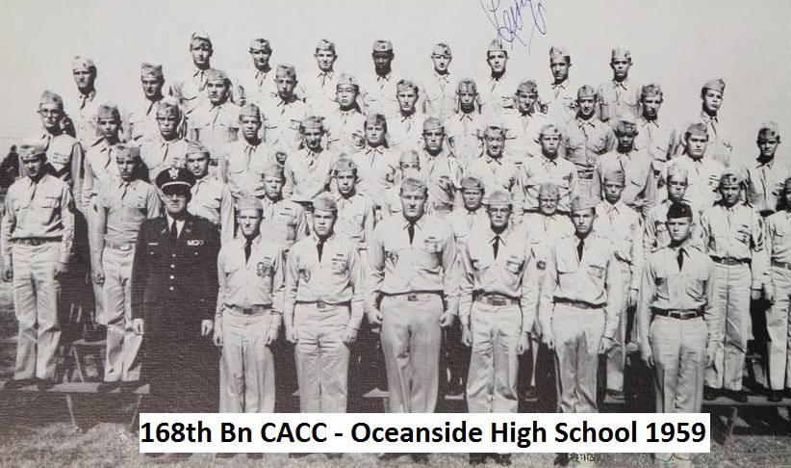

#### 

#### Red Beret for Survival

One Cadet Corps tradition is the awarding, and wearing of the Red Beret for completing the CACC-conducted survival course. This course is the most-difficult course in the Cadet Corps and successful completion means that cadets are entitled to wear the Red Beret.

#### 

#### General Joseph W. Stilwell Award

The **Stilwell Saber**, named after General **Joseph W. Stilwell,** is presented annually to the Outstanding Overall Cadet, Senior Division during the yearly state-level Individual Major Awards (IMAs).

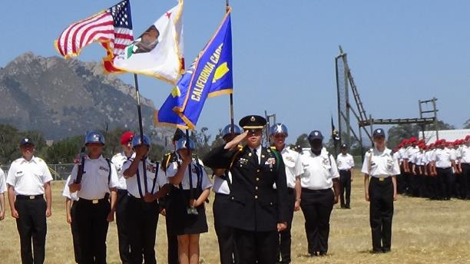

#### Summer Encampment

The Cadet Corps Summer Encampment began with the start of the program in the early 1900s. It was reestablished after a more than twenty year’s absence due to financial restrictions in 2013. Summer Encampment serves as an opportunity for Cadets to apply skills learned during the school year to realistic field experience as well as learn new skills that cannot be taught at the school level. It is also an opportunity for advanced Cadets to develop their leadership skills by planning, executing, and supervising many aspects of Summer Encampment.

#### 

#### Cadet Officers

Cadet Officer Candidates, although not officers, are often addressed as “sir” or “ma’am” due to being the highest-ranking cadet in a unit. The red pip has been used as the insignia for Officer Candidates. It is customary that a cadet who becomes a cadet officer gives a $1 bill to the first enlisted cadet that renders a salute.

#### 

#### Shoulder Cords

Shoulder cords in the CACC are used to denote positioning on a staff or special team with one exception. The Superior Uniform Shoulder Cord is awarded weekly to a cadet with the best uniform based on the weekly in-ranks inspection. In the CACC, cords of one solid color are worn on the left shoulder while cords of two colors are worn on the right shoulder.

Unit Names

Unit names given down to the squad level as an unofficial name. Traditionally the battalion adopts the school mascot or another prominent aspect of the school as part of its name, ex. Surfrider Battalion. Rough Riders Platoon. This carries over to some events like Drill Academy and XTC where small unit training and teamwork is emphasized.

#### Cadet Leadership

When an officer says that he wishes, or desires, or thinks it would be nice that something be done, cadets should consider that wish an order.

#### 

#### Hand Raising for a Question

Rather than raising an open hand, Cadets traditionally raise clenched fist when they have a question.

### A10. Every Day Courtesies

**(Adapted from Emily Post’s Website)**

<http://emilypost.com/advice/video-etiquette-and-the-story-of-king-louis-xiv/>

We learned most everyday courtesies that you will ever need in kindergarten, but no mater your age these essential words are effortless to say and convey a wealth of meaning to others. In the Cadet Corps, these courtesies are the foundation for creating positive interactions. Remember when you put on the uniform you represent not only yourself, but also your unit, the California National Guard, and the State of California.

#### “Please”

Using “please” expresses both respect and consideration for those with whom we’re interacting because it changes a command into a request. It sets the tone for whatever follows and is one of most important universal manners.

#### “Thank You” and “You’re Welcome”

Most people know to express their thanks for gifts, favors, awards, and the like. But we sometimes fail to recognize and show appreciation for the everyday courtesies that come our way, such as when someone holds the door or lets us go ahead in line. Expressing thanks for these little services is a hallmark of civility.

When someone says, “thank you,” the best response is, “you’re welcome.” Don’t be bashful—accept the credit for your kindness.  It’s subtle, but an “it was nothing” is actually saying that you place no value on what you did. By accepting thanks graciously, you can also encourage the “thank-you” habit.

#### “Excuse Me”

“Excuse me,” “pardon me,” and “I beg your pardon” all express your awareness that you’ve inconvenienced someone else. Make it a habit to excuse yourself whenever you do the following:

* Make a necessary interruption: “Excuse me, but you have a phone call.”
* Make a request: “Excuse me, but this is the non-smoking section.”
* Acknowledge an error: “Excuse me.  I didn’t realize that you were already waiting in line.”
* Acknowledge a faux pas, such as burping: “Excuse me.”
* Leave a conversation: “Excuse me, I wish I could chat longer, but I have to leave now.”
* Get up from the table: “Please excuse me.”

#### “I’m Sorry”

Making and accepting apologies gracefully are acts of courtesy and maturity, and they are important for matters both big and small. Sincere apologies can defuse volatile situations; it’s hard for most people to remain angry with someone who takes responsibility for his own actions. “I’m sorry” is also one of the simplest and often kindest ways to express sympathy or regret. A job loss, an illness, a death in the family, or the loss of a pet are all times when you might say sorry. At these times, keep it simple—you don’t need to elaborate if you aren’t sure what else to say.

### A11. Cadet Corps Taboos

Taboos are universal prohibitions of an action because these actions can bring discredit on the Cadet Corps or yourself, embarrass others, ambush established procedures, diminish respect, and result in broken relationships with others. These taboos have been established in the Cadet Corps over the past one hundred years:

* Never criticize the Cadet Corps or a leader in public. (This includes Social Media)
* Never go "over the heads" of superiors-don't jump the chain of command.
* Never offer excuses, unless asked to explain.
  + If you don't know the answer to a superior's question, you will never go wrong with the response, "Sir/Ma’am I do not know, but I'll find out.
* Never "wear" a superior's rank by saying something like, "the first sergeant wants this done now," when in fact the first sergeant said no such thing. Speak with your own voice.
* Never turn and walk away to avoid giving the hand salute.
* Never run indoors or pretend you don't hear (while driving, for example) to avoid standing reveille or retreat.
* Never chew gum while in uniform
* Never spread gossip or rumors
* Never use profanity or vulgar words
* Never walk or stand with your hands in your pockets

### A12. Grooming



Nothing succeeds like the appearance of success.

Christopher Lasch



#### Taking Care of Your Personal Image

The way you take care of your body and anything you put on it is an important part of your image. When you put on a uniform, it is an important part of your professional image. Paying attention to grooming and taking care with your uniform demonstrates respect for yourself and for others. The operative words are neat and clean.

#### Taking Care of Your Person

When you attend to personal grooming, do it at home or in a restroom, not in public. Consider the following:

* Hair: Clean, shiny, well-cut hair looks great and never goes out of style. Comb it often to keep it neat.
* Nails: The basics of nail care include neatly trimmed nails and cuticles, both of which can be done at home. If you wear polish, maintain it regularly. If you’re a nail biter, keep your nails short and filed to prevent them from looking ragged. And don’t forget your feet when wearing open-toed shoes!
* Breath: To keep breath fresh, try to brush your teeth after lunch as well as in the morning and at night. Regular flossing and brushing your tongue helps control odor. Breath mints can help, and it’s a good idea to keep some handy. If brushing, flossing, and mouthwash don’t take care of it, pay a visit to your dentist or doctor.
* Body odor: A daily bath or shower and use of a combination deodorant/antiperspirant is the best defense against body odor. So is showering before returning to work after a lunchtime workout.
* Perfume and cologne: Apply perfume or cologne sparingly. If your scent lingers in the room after you leave, you’re wearing too much. Unfortunately, the perfume you love may offend someone else or even cause an allergic reaction. Some workplaces have “no scent” policies, so check yours out. When choosing a scent, opt for something light for daytime or office.

#### Taking Care of Your Uniforms

Clothes send a message about how you want others to see you. Uniforms should be spotless at the start of the day; soiled or sloppy uniforms reflects on both you and your unit. Uniforms should be:

* Clean: Don’t be tempted to wear anything with spots or stains, or that’s just plain dirty. Sometimes even clean clothes may not be as fresh as they appear, so apply the sniff test.
* Neat: Clothes should be free of wrinkles, lint, holes, and missing buttons. Hems should be intact. Investing in a few clothing-care tools and learning how to use them is also a good idea. Some of the basics are:
  + Iron and ironing board: Learn how to iron a blouse or dress shirt, trousers, and skirt.
  + Clothes brush or lint roller: Hang one on the back of your closet door. Even if your uniform is clean, lint and pet hair will detract from your appearance.
  + Basic sewing kit: Learn how to sew on a button and repair a basic hem.
  + Shoe shine kit: Regular care of your shoes—and other leather goods—makes them look great and protects your investment.

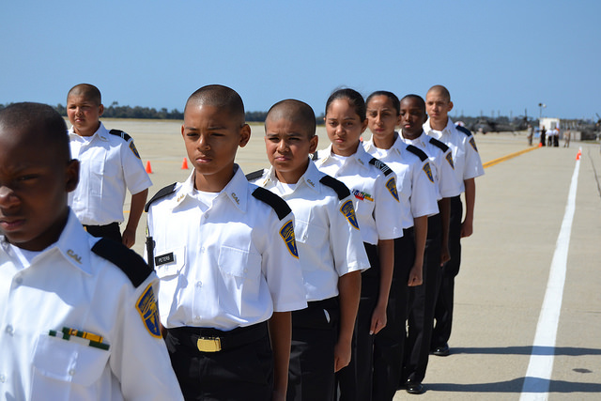(The Emily Post Institute, Inc, 2016)

Grooming reflects positively, or negatively, on you. While wearing the CACC uniform, grooming reflects on your school, the California Cadet Corps, and the State of California.

### A13. Helping Others

If an older woman or an invalid gentleman wants some support, it is appropriate for you to offer your arm. The cadet does not offer his or her hand. Hand holding in public is not appropriate and is considered a public display of affection, which is improper when in uniform. A cadet may offer his or her hand only when it is not practical to offer the arm, for example, to help an elderly lady or gentleman out of a car. Offer your hand palm up, and do not force it upon the person to whom you are offering it; then, withdraw your hand as soon as it is no longer needed. When walking with a lady, a gentleman may walk on the curbside, or on her left if there is no curb. If a gentleman arrives at a door first, he should open it and allow others to pass through. If a lady arrives at the door first and opens it, the gentleman may hold the door for her to continue.

If you are driving or riding to a social event in a privately-owned vehicle, open the car door for your passenger first on the right side of the car, then go around it and take your seat, either behind the wheel or in the back seat beside your guest. When you reach your destination, walk around the car and open the door for your guest if he or she has not already exited the vehicle.



What does love look like? It has the hands to help others. It has the feet to hasten to the poor and needy. It has eyes to see misery and want. It has the ears to hear the sighs and sorrows of men. That is what love looks like.

St. Augustine



### A14. Chain of Command

In the Cadet Corps, as in the Military, the chain of command is the line of authority and responsibility along which orders are passed and executed. Orders are passed from a higher-ranked cadet, such as an officer, to a lower-ranked individual to execute the order, or pass it down the chain as needed.

In general, Cadets should only give orders to subordinate cadets within their chain of command, and receive orders only from those directly above them. This means that having a higher rank alone, does not entitle a leader of Unit A to give an order to a Cadet in Unit B. The chain of command means that individual members take orders from one superior and only to those subordinates appointed under them. However, it is the responsibility of every cadet leader to make corrections as necessary. For example, if you witness a cadet not saluting an officer, or wearing a uniform improperly, you should politely correct the cadet and tell them to fix the problem. The following diagram shows the chain of command from the Governor of California all the way down to the brand-new-Recruit in a squad.



In the military, there is generally only one chain of command running from the President down to the brand-new-recruit. However, the CACC is a military-like program that occurs in California schools and as a result it has three chains of command. The Cadet Chain of Command allows the program to be an “applied leadership” program by putting cadets in charge from the squad level all the way up to the corps level. The School Chain of Command ensures cadets are responsible to their school leadership and its educational goals. The CACC Chain of Command ensures cadets are responsible to the Cadet Corps leadership and its program goals.

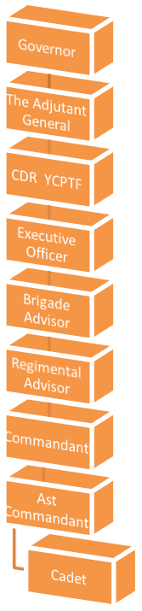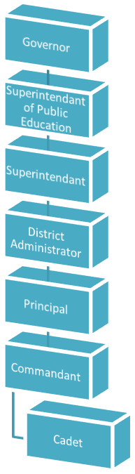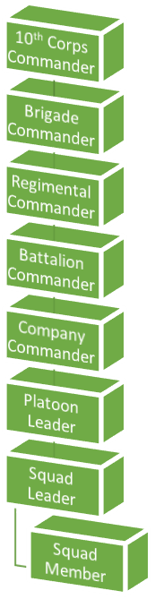

**Cadet Chain**

**CACC Chain**

**School Chain**

**Breaking the Chain:**

**An Explanation of the Various Chains at work in the**

**California Cadet Corps**

By Lieutenant Colonel Mark Ryan, California Cadet Corps

The formal definition of the Cadet Corps Chain of Command is “the succession of commanding officers from superior to subordinate levels”. It consists of people whom the LAWS OF CALIFORNIA give authority to exercise control over Cadet Corps activities. Because we are a complex organization with cadets, adult members, and school/district administrators, we actually have several chains of command. The cadet chain starts with the squad leader at the lowest level of command, proceeds to the Platoon Leader, Company Commander, Battalion Commander, Brigade Commander, and 10th Corps Commander. Another chain goes from the cadet through the Commandant, Principal of the School, Administrator at the School District, Superintendent of Public Instruction, to the Governor. Finally, a chain goes through the Commandant, the Brigade Advisor, Cadet Corps Executive Officer, Commander of the CA National Guard Youth and Community Programs Task Force, Adjutant General, to the Governor. See the charts on the previous page to visually see how this flows. A cadet with a normal issue should take it to his/her Squad Leader. But there are times when it’s appropriate to go directly to the Commandant.

To complicate matters even further, there are three other “Chains” to consider. Let’s look at them one at a time. The first is commonly called the Chain of Concern. This chain is the chain of “who you see when you have a problem, need a question answered, or need help with something.” For instance, a squad member might see his/her assistant squad leader before going to the squad leader. Squad leaders would likely see the platoon sergeant before going to the platoon leader. Platoon sergeants might ask their company first sergeant for assistance instead of going through the Platoon Leader. The Chain of

Concern is the path you take to get your questions answered and concerns addressed.

The Chain of Concern is not written down in the same way the Chain of Command is; however, it might look like this:

* Squad members ask assistant squad leaders or squad leaders
* Squad leaders ask platoon sergeants
* Platoon sergeants ask platoon leaders or company first sergeants
* Platoon leaders ask company commanders
* Company first sergeants ask company commanders or battalion sergeants major or might ask an NCO in one of the staff sections (S-1, S-3, S4, etc.)
* Company commanders ask battalion commanders or one of the Staff Officers (S-1, S3, S-4)
* And so on

Then there is the NCO support channel. There is a formal chain of non-commissioned officers who support the commanders they work for. As a general rule, these NCOs communicate with each other through this separate chain as they perform their daily duties. That chain looks like this:

**BRIGADE COMMAND SERGEANT MAJOR**

**BATTALION COMMAND SERGEANT MAJOR**

**COMPANY FIRST SERGEANT**

**PLATOON SERGEANT**

**SQUAD LEADER**

Finally, there is the Staff Support Channel. While the Commanders and NCOs are doing their various jobs, there are Staff NCOs and Officers who perform the functions of personnel and administration management, training and operations planning, supply and logistics support, and public and government affairs work. That “Chain” looks something like this:

* At the company level, this includes clerks, a supply sergeant, sometimes a personnel/administration sergeant, and sometimes a training sergeant
* At the battalion level, this includes an S-1, S-3, S-4, and S-5 and various assistants and NCOs who work in those staff sections.
* At the brigade level, this includes another layer of S-1s, S-3s, S-4s, and S-5s and even more assistants and NCOs who work in those departments.

#### Practical Exercise

*Have each squad work as a team. Discuss each of the scenarios listed here. Describe how the chain of command or NCO Support Chain would deal with each of these issues:*

*1. Squad Leader has a cadet who has missed class or practice multiple times.*

*2. Squad Leader has a cadet who has been promoted, but hasn’t received the insignia for their uniform.*

*3. Cadet Battalion Commander sees a posting on Facebook by a cadet, saying derogatory things about his Platoon Sergeant.*

*4. Commandant needs a cadet to bring in a permission slip to attend a weekend activity.*

*5. Battalion S1 is preparing for the AGI, and needs to verify the Form 13s for accuracy. She wants each cadet to review their Form 13.*

To put it all together, the chart on the following page shows the Chain of Command in the center and the NCO and Staff Support Channels on each side. Even though there are only a few people who have formal command authority and are represented in the center of the chart, you can see a great many people who work with those commanders to support the many responsibilities of command.

|  |  |  |
| --- | --- | --- |
| **NCO SUPPORT CHANNEL**  **(Part of the Chain of**  **Concern)** | **CHAIN OF COMMAND** | **STAFF SUPPORT**  **CHANNEL**  **(Part of the Chain of**  **Concern)** |
| **10th Corps Command**  **Sergeant Major** | **Governor**  **Adjutant General**  **Executive Officer**  **10th Corps Commander**  **(At State Events)** | **10th Corps S-1, S-3, S-4, S-5** |
| **Brigade Command Sergeant Major** | **Brigade Advisor**  **Cadet Brigade Commander** | **Brigade S-1, S-3, S-4, S-5** |
| **Battalion Command Sergeant**  **Major** | **Principal**  **Commandant of Cadets**  **Battalion Commander** | **Battalion S-1, S-3, S-4, S-5** |
| **Company First Sergeant** | **Company Commander** | **Company Clerk**  **Supply Sergeant**  **Training Sergeant** |
| **Platoon Sergeant** | **Platoon Leader** | **Generally, none** |
| **Assistant Squad Leader** | **Squad Leader** | **None** |

### A. Everyday Courtesies Vocabulary:

* + adjutant
  + allegiance
  + authority
  + bashful
  + capabilities
  + chevrons
  + commission (officer)
  + company grade
  + encampment
  + encumbered
  + etiquette
  + express
  + facilitate
  + faux pas
  + field grade
  + harmonious
  + interactions
  + invalid
  + NCO
  + pledge
  + render
  + responsibility
  + Retreat (song)
  + Reveille (song)
  + servility
  + subordinate
  + superior
  + symbolic
  + taboo
  + tactfully
  + volatile
  + warrant (officer)

## References

Powers, R. (2016, October 14). *The History of American Military Rank*. Retrieved from The Balance: https://www.thebalance.com/military-rank-history-3354123

The Emily Post Institute, Inc. (2016, November 8). *Good Grooming and Wardrobe Care*. Retrieved from Emilypost.com: http://emilypost.com/advice/good-grooming-and-wardrobe-care/

The Emily Post Institute, Inc. (2016, 11 18). *Advice, Anna Post on Managing Mobile Manners*. Retrieved from emilypost.com: http://emilypost.com/advice/anna-post-on-managing-mobile-manners/

The Emily Post Institute, Inc. (2016, 11 14). *Invitation Etiquette*. Retrieved from EmilyPost.com: http://emilypost.com/advice/invitation-etiquette/

The Emily Post Institute, Inc. (2016, 11 14). *Invitation Timing*. Retrieved from emilypost.com: http://emilypost.com/advice/invitation-timing/

The Emily Post Institute, Inc. (2016, November 8). *Job Interview Tips 101*. Retrieved from emilypost.com: http://emilypost.com/advice/job-interview-tips-101/

The Emily Post Institute, Inc. (2016, November 8). *Job Interview Tips 101*. Retrieved from emilypost.com: http://emilypost.com/advice/job-interview-tips-101/

US Army. (2006). *FM 3-21.5.* Washington DC: HQ, US Army.

United States Army Infantry School Handout. Formal Dining In. May 1985. 2D Training Battalion (IOBC). The School Brigade. United States Army Infantry School. Ft. Benning, Ga.

United States Army Sergeants Major Academy Handbook. Protocol and etiquette. Headquarters, USASMA. Ft. Bliss, TX.

United States Military Academy Pamphlet. Guide to Military Dining-in. USMA, West Point, NY.

Crocker, Lieutenant Colonel Lawrence P., U. S. Army, Retired. The Army Officer’s Guide. 1981. 41st Edition. The Stackpole Company, Harrisburg, PA.

Crossley, Ann and Keller, Carol. A. The Army Wife Handbook. 1993. 2nd Edition. ABI Press Sarasota, FL.

Swartz, Oretha D. Service Etiquette. 1988. 4th Edition. U. S. Naval Institute, Annapolis, MD.

## Videos

Introduction to Military Customs and Courtesies, CACC, CW3 Sirkin (9 minutes):

<https://youtu.be/7sL9tjrCrQ4>